Table of Contents

TRAILER MODEL DESIGNATION

NATM Model Trailer User’s Manual
^WARNING
Thuro-Bilt, Inc.
885 Flournoy Valley Rd
Roseburg, OR 97471
www.thuro-bilt.com
541-670-8701
thurobilttrailers@gmail.com

THURO-BILT, INC.

^WARNING
This User’s Manual contains safety information and instructions for your trailer.

You must read this manual before loading or
towing your trailer.

You must follow all safety precautions and instructions.

i
Table of Contents
TRAILER MODEL DESIGNATION
1. GENERAL SAFETY INFORMATION ...........................................................................................................1
1.1. Safety Alert Symbols & Signal Words........................................................................................................1
1.2. Major Hazards............................................................................................................................................1
1.3. Improper Sizing of the Trailer to the Tow Vehicle......................................................................................2
1.4. Driving Too Fast .......................................................................................................................................2
1.5. Failure to Adjust Driving Behavior When Towing a Trailer .......................................................................2
1.6. Trailer Not Properly Coupled to the Hitch..................................................................................................3
1.7. Proper Use of Safety Chains ....................................................................................................................4
1.8. Proper Connection of Breakaway Brake System......................................................................................4
1.9. Matching Trailer & Hitch............................................................................................................................5
1.10. Worn Tires, Loose Wheels & Lug Nuts...................................................................................................5
1.11. Improper Loading....................................................................................................................................6
1.12. Unsafe Load Distribution ........................................................................................................................7
1.13. Shifting Cargo.........................................................................................................................................8
1.14. Inappropriate Cargo................................................................................................................................8
1.15. Inoperable Brakes, Lights or Mirrors.......................................................................................................9
1.16. Hazards From Modifying Your Trailer....................................................................................................10
1.17. Hazards to Horses (Horse Trailer).........................................................................................................10
1.18. Hazards to Livestock (Livestock Trailer)................................................................................................11
1.19. Hazards from Accessories.....................................................................................................................12
1.20. Generator...............................................................................................................................................12
1.21. Shore Power .........................................................................................................................................13
1.22. LP Gas Fuel System ............................................................................................................................14
1.23. Safety Warning Labels on Your Trailer.................................................................................................15
1.24. Trailer Towing Guide ...........................................................................................................................15
1.25. Reporting Safety Defects.....................................................................................................................16
1.26. Safe Trailer Towing Guidelines............................................................................................................17
2. TIRE SAFETY INFORMATION................................................................................................................18
2.1. Steps for Determining Correct Load Limit - Trailer................................................................................18
2.2. Trailers 10,000lbs GVWR or Less ........................................................................................................18
2.3. Trailers Over 10,000lbs GVWR.............................................................................................................19
2.4. Steps for Determining Correct Load Limit - Tow Vehicle.......................................................................19
2.5. Glossary of Tire Terminology................................................................................................................19
2.6. Tire Safety - Everything Rides on it.......................................................................................................23
2.7. Safety First–Basic Tire Maintenance.....................................................................................................23
2.8. Finding Your Vehicle's Recommended Tire Pressure & Load Limits....................................................23
2.9. Understanding Tire Pressure & Load Limits .......................................................................................24
2.10. Checking Tire Pressure .....................................................................................................................24
2.11. Steps for Maintaining Proper Tire Pressure ......................................................................................24
2.12. Tire Size.............................................................................................................................................25
2.13. Tire Tread ..........................................................................................................................................25
2.14. Tire Balance & Wheel Alignment .......................................................................................................25
2.15. Tire Repair .........................................................................................................................................25
2.16. Tire Fundamentals..............................................................................................................................25
2.17. Information on Passenger Vehicle Tires.............................................................................................25
2.18. UTQGS Information ...........................................................................................................................27
2.19. Additional Information on Light Truck Tires........................................................................................28
2.20. Tire Safety Tips...................................................................................................................................28
3. COUPLING TO THE TOW VEHICLE .....................................................................................................29
3.1. Use an Adequate Tow Vehicle & Hitch ................................................................................................29
3.2. Trailer Information.................................................................................................................................30
3.3. Coupling & Uncoupling the Trailer........................................................................................................32
3.4. Various Coupler Designs......................................................................................................................33
3.5. Trailer with Ball-Hitch Coupler .............................................................................................................34

ii

Table of Contents

TRAILER MODEL DESIGNATION

3.6. Before Coupling the Trailer to the Tow Vehicle ...................................................................................34
3.7. Prepare the Coupler & Hitch................................................................................................................ 35
3.8. Couple the Trailer to the Tow Vehicle.................................................................................................. 36
3.9. Rig the Safety Chains ......................................................................................................................... 37
3.10. Attach & Test Electric Breakaway Brake System.............................................................................. 38
3.11. Connect the Electrical Cables........................................................................................................... 41
3.12. Uncoupling the Ball Hitch Trailer with Tongue Jack.......................................................................... 41
3.13. Trailer with Gooseneck Coupler & Drop-leg Jack ............................................................................ 41
3.14. Prepare the Ball Receiver & Gooseneck Ball................................................................................... 45
3.15. Couple the Trailer to the Tow Vehicle.............................................................................................. 46
3.16. Rig the Safety Chains ...................................................................................................................... 47
3.17. Attach & Test the Breakaway Brake System ................................................................................... 48
3.18. Connect the Electrical Cables.......................................................................................................... 50
3.19. Uncoupling the Gooseneck Trailer with Drop-leg Jack ................................................................... 50
3.20. Trailer with Fifth-wheel Coupler & Drop-leg Jack ............................................................................ 52
3.21. Before Attempting to Tow the Trailer................................................................................................ 52
3.22. Raise the Drop Leg Jack ................................................................................................................. 54
3.23. Attach & Test the Breakaway Brake System ................................................................................... 55
3.24. Connect the Electrical Cables........................................................................................................... 56
3.25. Uncoupling the Fifth-Wheel Trailer with Drop-leg Jack..................................................................... 57
4. LOADING THE TRAILER...................................................................................................................... 59
4.1. Tongue Weight ................................................................................................................................... 59
4.2. Checking Tongue Weight..................................................................................................................... 61
4.3. Securing the Cargo.............................................................................................................................. 62
4.4. Loading Cargo (Enclosed Trailer) ....................................................................................................... 62
4.5. Preparing the Trailer for Loading......................................................................................................... 63
4.6. Loading the Enclosed Trailer............................................................................................................... 63
4.7. Loading Horses (Horse Trailer)............................................................................................................ 64
4.8. Preparing the Horse Trailer for Loading .............................................................................................. 65
4.9. Loading the Horse Trailer .................................................................................................................... 66
4.10. Loading Livestock (Livestock Trailer)................................................................................................. 68
4.11. Preparing the Livestock Trailer for Loading ....................................................................................... 69
4.12. Loading the Livestock Trailer.............................................................................................................. 70
5. CHECKING THE TRAILER BEFORE & DURING EACH TOW ............................................................. 71
5.1. Pre-tow Checklist .................................................................................................................................. 71
5.2. Make Regular Stops.............................................................................................................................. 71
6. BREAKING-IN A NEW TRAILER ........................................................................................................... 72
6.1. Retighten Lug Nuts at First 10,25 & 50 Miles........................................................................................ 72
6.2. Adjust Brake Shoes at First 200 Miles................................................................................................... 72
6.3. Synchronizing the Brake Systems......................................................................................................... 72
7. INSPECTION, SERVICE & MAINTENANCE........................................................................................... 73
7.1. Inspection, Service & Maintenance Summary Charts .......................................................................... 73
7.2. Inspection & Service Instructions.......................................................................................................... 75
7.3. Trailer Structure ................................................................................................................................... 75
7.4. Welds ................................................................................................................................................... 76
7.5. Drop Ramp Torsion Springs ................................................................................................................ 76
7.6. Brake Shoes & Drums ......................................................................................................................... 76
7.7. Manually Adjusting Brake Shoes.......................................................................................................... 76
7.8. Brakes, Electric .................................................................................................................................... 77
7.9. Breakaway Break…………………………………………………………………………………………………77

iii

Table of Contents

TRAILER MODEL DESIGNATION

7.10.Tow Vehicle Operated Electric Brakes……………….......................................................................... 77
7.11. Magnets for all Electric Brakes……………………….......................................................................... 78
7.12. Brakes, Hydraulic (Vacuum, Air or Electric Operated) ..................................................................... 78
7.13. Vacuum-Operated Hydraulic…………………………......................................................................... 78
7.14. Air Pressure-Operated Hydraulic…………………….......................................................................... 78
7.15. Electrical-Operated Hydraulic…………………………........................................................................ 78
7.16. Coupler & Ball .................................................................................................................................. 78
7.17. Gooseneck .........................................................................................................................................79
7.18. Fifth Wheel Kingpin ........................................................................................................................... 79
7.19. Landing Leg or Jack........................................................................................................................... 79
7.20. Lights & Signals .................................................................................................................................79
7.21. Accessory Battery...............................................................................................................................80
7.22. Tires.....................................................................................................................................................80
7.23. Wheel Rims .........................................................................................................................................81
7.24. Wheels, Bearings & Lug Nuts ............................................................................................................81
7.25. Unsealed Bearings (Hubs) ..................................................................................................................81
7.26. Lug Nuts (Bolts) ..................................................................................................................................82
8. WARNING STICKERS ON THE TRAILER............................................................................................. 84

iv
General Safety Information

- GENERAL SAFETY INFORMATION

1.1. SAFETY ALERT SYMBOLS & SIGNAL WORDS
An Owner’s Manual that provides general trailer information cannot cover all of the specific details necessary
for the proper combination of every trailer, tow vehicle and hitch. Therefore, you must read, understand and
follow the instructions given by the tow vehicle and trailer hitch manufacturers, as well as the instructions in this
manual.

Our trailers are built with components produced by various manufacturers. Some of these items have separate
instruction manuals. Where this manual indicates that you should read another manual, and you do not have
that manual, call Thuro-Bilt, Inc at 541-670-8701 for a free copy.

The safety information in this manual is denoted by the safety alert symbol: ^
The level of risk is indicated by the following signal words.

^ DANGER
DANGER – Immediate hazards which WILL
result in severe personal injury or death if the
warning is ignored.
^WARNING

^WARNING
WARNING – Hazards or unsafe practices
which COULD result in severe personal injury
or death if the warning is ignored.

^ CAUTION
CAUTION – Hazards or unsafe practices
which could result in minor or moderate injury
if the warning is ignored.

^NOTICE
NOTICE – Practices that could result in
damage to the trailer or other property.

1.2. MAJOR HAZARDS
Loss of control of the trailer or trailer/tow vehicle combination can result in death or serious injury. The most
common causes for loss of control of the trailer are:

• Improper sizing the trailer for the tow vehicle, or vice versa.
• Excessive Speed: Driving too fast for the conditions.
• Failure to adjust driving behavior when towing a trailer.

1
General Safety Information

• Overloading and/or improper weight distribution.
• Improper or mis-coupling of the trailer to the hitch.
• Improper braking and steering under sway conditions.
• Not maintaining proper tire pressure.
• Not keeping lug nuts tight.

1.3. IMPROPER SIZING OF THE TRAILER TO THE TOW VEHICLE
Trailers that weigh too much for the towing vehicle can cause stability problems, which can lead to death or
serious injury. Furthermore, the additional strain put on the engine and drive-train may lead to serious tow
vehicle maintenance problems. For these reasons the maximum towing capacity of your towing vehicle should
not be exceeded. The towing capacity of your tow vehicle, in terms of maximum Gross Trailer Weight (GTW)
and maximum Gross Combined Weight Rating (GCWR) can be found in the tow vehicles Owner’s Manual.

^ DANGER
Use of a tow vehicle with a towing capacity
less than the Gross Vehicle Weight Rating of
the trailer can result in loss of control, and may lead to death or serious injury.

Be sure your hitch and tow vehicle are rated
for the Gross Vehicle Weight Rating of your
trailer.

1.4. DRIVING TOO FAST
With ideal road conditions, the maximum recommended speed for safely towing a trailer is 60 mph. If you drive
too fast, the trailer is more likely to sway, thus increasing the possibility for loss of control. Also your tires may overheat, thus increasing the possibility of a blowout.

^WARNING
Driving too fast for conditions can result in loss of control and cause death or serious injury.

Decrease your speed when going downhill or
as road, weather, and lighting conditions
deteriorate.

1.5. FAILURE TO ADJUST DRIVING BEHAVIOR WHEN TOWING A TRAILER
When towing a trailer, you will have decreased acceleration, increased stopping distance, and increased
turning radius (which means you must make wider turns to keep from hitting curbs, vehicles, and anything else
that is on the inside corner). Furthermore the trailer will change the handling characteristics of your towing
vehicle, making it more sensitive to steering inputs and more likely to be pushed around in windy conditions or
when being passed by large vehicles. In addition, you will need a longer distance to pass, due to slower
acceleration and increased length. With these caveats in mind:

• Be alert for slippery conditions. You are more likely to be affected by slippery road surfaces when
driving a tow vehicle with a trailer, than driving a tow vehicle without a trailer.
• Anticipate the trailer “swaying.” Swaying can be caused by excessive steering, wind gusts, roadway
edges, or by the trailer reaction to the pressure wave created by passing trucks and busses.
• When encountering trailer sway take your foot off the gas, and steer as little as possible in order to stay
on the road. Use small “trim-like” steering adjustments. Do not attempt to steer out of the sway; you’ll

2
General Safety Information

only make it worse. Also do not apply the tow vehicle brakes to correct trailer swaying. On the other
hand, application of the trailer brakes alone will tend to straighten out the combination, especially when
going downhill.
• Check rearview mirrors frequently to observe the trailer and traffic.
• Use lower gear when driving down steep or long grades. Use the engine and transmission as a brake.
Do not ride the brakes, as they can overheat and become ineffective.
• Be aware of your trailer height, especially when approaching bridges, roofed areas and around trees.

1.6. TRAILER NOT PROPERLY COUPLED TO THE HITCH
It is critical that the trailer be securely coupled to the hitch ball, and that the safety chains and emergency
break-away brake cable is correctly attached. Uncoupling may result in death or serious injury to you and to
others.

^WARNING
Proper selection and condition of the coupler
and hitch are essential to safely towing your
trailer. A loss of coupling may result in death
or serious injury.

• Be sure the maximum load rating of the
hitch on the tow vehicle is equal to or
greater than the maximum load rating of the
coupler on the trailer.

• Be sure the hitch ball size matches the
coupler size.

• Observe the hitch for wear, corrosion and
cracks before coupling. Replace worn,
corroded or cracked hitch components
before coupling the trailer to the tow vehicle.

• Be sure the hitch components are tight
before coupling the trailer to the tow vehicle.

3
General Safety Information
^
^WARNING
An improperly coupled trailer can result in
death or serious injury.

Do not move the trailer until:
• The coupler is secured and locked to hitch ball;
• The safety chains are secured to the tow
vehicle; and
• The trailer jack(s) are fully retracted.

Do not tow the trailer on the road until:
• Tires and wheels are checked;
• The trailer brakes are checked;
• The breakaway switch is connected to the
tow vehicle;
• The load is secured to the trailer; and
• The trailer lights are connected and checked.

1.7. PROPER USE OF SAFETY CHAINS
If your trailer comes loose from the hitch for any reason, we have provided safety chains so that control of the
trailer can still be maintained

^WARNING
Improper rigging of the safety chains can result in loss of control of the trailer and tow vehicle, leading to death or serious injury, if the trailer uncouples from the tow vehicle.

• Fasten chains to frame of tow vehicle. Do
not fasten chains to any part of the hitch
unless the hitch has holes or loops
specifically for that purpose.

• Cross chains underneath hitch and coupler
with enough slack to permit turning and to
hold tongue up, if the trailer comes loose.

1.8. PROPER CONNECTION OF BREAKAWAY BRAKE SYSTEM
If equipped with brakes your trailer will be equipped with a breakaway brake system that can apply the brakes
on your trailer if your trailer comes loose from the hitch ball for any reason.
^WARNING

4
General Safety Information
^
^WARNING
An ineffective or inoperative breakaway brake
system can result in a runaway trailer, leading
to death or serious injury, if the coupler or hitch fails.
The breakaway cable must be connected to
the tow vehicle; and NOT to any part of the
hitch.
Before towing the trailer, test the function of
the breakaway brake system. If the breakaway
brake system is not working, do not tow the
trailer; have it serviced or repaired.

1.9. MATCHING TRAILER & HITCH

^ DANGER
Use of a hitch with a load rating less than the
load rating of the trailer can result in loss of
control and may lead to death or serious injury.

1.10. WORN TIRES, LOOSE WHEELS & LUG NUTS
Just as with your tow vehicle the trailer tires and wheels are important safety items. Therefore, it is essential to
inspect the trailer tires before each tow.

If a tire has a bald spot, bulge, cut, cracks, or is showing any cords, replace the tire before towing. If a tire has
uneven tread wear, take the trailer to a dealer service center for diagnosis. Uneven tread wear can be caused
by tire imbalance, axle misalignment or incorrect inflation.

Tires with too little tread will not provide adequate frictional forces on wet roadways and can result in loss of
control, leading to death or serious injury.

Improper tire pressure causes increased tire wear and may reduce trailer stability, which can result in a tire
blowout or possible loss of control. Therefore, before each tow you must also check the tire pressure.

Remember, the proper tire pressure is listed on the Certification / VIN label, normally mounted on front left side
of the trailer, and should be checked when tires are cold. Allow 3 hours cool-down after driving as much as 1
mile at 40 mph before checking tire pressure.

^WARNING
Improper tire pressure can result in a blowout
and loss of control, which can lead to death or
serious injury.
Be sure tires are inflated to pressure indicated
on the Certification/VIN label before towing
trailer.

The tightness of the lug nuts is very important in keeping the wheels properly seated to the hub.
Before each tow, check to make sure they are tight.

5
General Safety Information
^WA
^WARNING
Metal creep between the wheel rim and hub
may cause lug nuts to loosen and could result
in a wheel coming off, leading to death or
serious injury.
Tighten lug nuts before each tow.

The proper tightness (torque) for lug nuts is listed in Section 7.26 in the “Inspection and Service & Maintenance”
chapter of this manual. Use a torque wrench to tighten the lug nuts, use the crisscross star
pattern. If you do not have a torque wrench, use a lug wrench (from your tow vehicle) and tighten
the nuts as much as you can. At the first opportunity, have a service garage or trailer dealer tighten the lug
nuts to the proper torque.

Lug nuts are also prone to loosen after first being assembled. When driving a new trailer (or after wheels have
been remounted), check to make sure they are tight after the first 10, 25 and 50 miles of driving and before
each tow thereafter.

Failure to perform this check can result in a wheel separating from the trailer and a crash, leading to death or
serious injury.

^WARNING
Lug nuts are prone to loosen after initial
installation, which can lead to death or serious injury.

Check lug nuts for tightness on a new trailer or
when wheel(s) have been remounted after the
first 10, 25 and 50 miles of driving.

^WARNING
Improper lug nut torque can cause a wheel
separating from the trailer, leading to death or
serious injury.

Be sure lug nuts are tight before each tow.

1.11. IMPROPER LOADING
The total weight of the load you put in or on the trailer, plus the empty weight of the trailer itself, must not
exceed the trailer's Gross Vehicle Weight Rating (GVWR). If you do not know the empty weight of the trailer
plus the cargo weight, you must weigh the loaded trailer at a commercial scale. In addition, you must distribute
the load in the trailer such that the load on any axle does not exceed the Gross Axle Weight Rating (GAWR). If
your trailer is equipped with a Tire & Loading Information Placard, mounted next to the Certification / VIN label,
the cargo capacity weight stated on that placard is only a close estimate. The GVWR and GAWR’s are listed
on the Certification / VIN label mounted on the front left side of the trailer.

6
General Safety Information

^WARNING
An overloaded trailer can result in loss of
control of the trailer, leading to death or serious injury.

Do not exceed the trailer Gross Vehicle Weight
Rating (GVWR) or an axle Gross Axle Weight
Rating (GAWR).

Do not load a trailer so that the weight on any
tire exceeds its rating.

1.12. UNSAFE LOAD DISTRIBUTION
Improper front / rear load distribution can lead to poor trailer sway stability or poor tow vehicle handling. Poor
trailer sway stability results from tongue weights that are too low, and poor tow vehicle stability results from
tongue weights that are too high. Refer to Chapter heading “Loading the Trailer” for more information.

In the table below, the second column shows the rule of thumb percentage of total weight of the trailer plus its
cargo (Gross Trailer Weight, or “GTW”) that should appear on the tongue of the trailer. For example, a trailer
with a gooseneck hitch, with a loaded weight of 12,000 pounds, should have 20-25% of 12,000 pounds (2400-
3000 lbs.) on the gooseneck. A dump trailer will have the proper weight distribution if the load is evenly
distributed in the dump bed. For non-flowable (discrete) loads locate the load such as to provide the proper
tongue weight.

After loading, be sure to check that none of the axles are overloaded.

Tongue Weight as a Percentage of Loaded Trailer Weight

Type of Hitch | Percentage
Ball Hitch (or Bumper Hitch) | 10–15%for large trailers  6-10% for smaller utility and cargo trailers  4-6% for boat trailers
Gooseneck or Fifth Wheel Hitch | 20–25%

The numbers quoted above are for example purposes only and should be tailored to the specific trailer.
For questions regarding the actual percent of tongue weight for the trailer, check with the manufacturer
for specifics.

Uneven left / right load distribution can cause tire, wheel, axle or structural failure. Be sure your trailer is evenly
loaded left / right. Towing stability also depends on keeping the center of gravity as low as possible.

7
General Safety Information

^WARNING
Improper tongue weight (load distribution) can
result in loss of control of the trailer, leading to
death or serious injury.

Make certain that tongue weight is within the
allowable range.

Be sure to:
• Distribute the load front-to-rear to provide
proper tongue weight (see chart above). For dump trailers a flowable load should be evenly
distributed throughout the bed.
• Distribute the load evenly, right and left.
• Keep the center of gravity low.

1.13. SHIFTING CARGO
Since the trailer “ride” can be bumpy and rough, you must secure your cargo so that it does not shift while the
trailer is being towed.

^WARNING
Shifting cargo can result in loss of control of
the trailer, and can lead to death or serious injury.

Tie down all loads with proper sized fasteners,
ropes, straps, etc.

If the door latch is equipped with a catch that has a hole for a linchpin, use a linchpin to prevent the door latch from opening.

^WARNING
If the door opens, your cargo may be ejected
onto the road, resulting in death or serious
injury to other drivers.

Always secure the door latch after closing.

Place a linchpin in the catch.

1.14. INAPPROPRIATE CARGO
Your trailer may be designed for specific cargo, for example, only for horses. If your trailer is designed for
specific cargo, only carry that cargo in the trailer. A utility trailer must not be used to carry certain items, such
as people, containers of hazardous substances or containers of flammable substances.

8
General Safety Information

^WARNING
Do not transport people inside the trailer, even
if it has living quarters. The transport of
people puts their lives at risk and may be
illegal.
^
^WARNING
Do not transport flammable, explosive,
poisonous or other dangerous materials in your trailer.

Exceptions:
• Fuel in the tanks of vehicles that are being
towed
• Fuel stored in proper containers used in
trailer living quarters for cooking
• Fuel stored in the tank of an on-board generator.

1.15. INOPERABLE BRAKES, LIGHTS OR MIRRORS
Be sure that the electric brakes and all of the lights on your trailer are functioning properly before towing your
trailer. Electric brakes and lights on a trailer are controlled via a connection to the tow vehicle, generally a
multi-pin electrical connector. Check the trailer tail lights by turning on your tow vehicle headlights. Check the
trailer brake lights by having someone step on the tow vehicle brake pedal while you look at trailer lights. Do
the same thing to check the turn signal lights.

If your trailer has electric brakes, your tow vehicle will have an electric brake controller that sends power to the
trailer brakes. Before towing the trailer on the road, you must operate the brake controller while trying to pull
the trailer in order to confirm that the electric brakes operate. While towing the trailer at less than 5 mph,
manually operate the electric brake controller in the tow vehicle cab. You should feel the operation of the trailer
brakes.

^WARNING
Improper electrical connection between the tow vehicle and the trailer will result in inoperable lights and electric brakes, and can lead to collision.

Before each tow:
• Check that the taillights, brake lights and
turn signals work
• Check that the electric brakes work by
operating the brake controller inside the tow
vehicle.

If your trailer has hydraulic “surge” brakes, pull the emergency break-away brake lanyard to check the
operation of the surge mechanism.

9
General Safety Information

Standard mirrors usually do not provide adequate visibility for viewing traffic to the sides and rear a towed
trailer. You must provide mirrors that allow you to safely observe approaching traffic.

1.16. HAZARDS FROM MODIFYING YOUR TRAILER
Essential safety items can be damaged by altering your trailer. Even simply driving a nail or screw to hang
something can damage an electrical circuit, LP gas line or other feature of the trailer.

Before making any alteration to your trailer, contact your dealer and describe the alteration you are contemplating. Alteration of the trailer structure or modification of mechanical, electrical, plumbing, heating or other systems on your trailer must be performed only by qualified technicians who are familiar with the system as installed on your trailer.

1.17. HAZARDS TO HORSES (HORSE TRAILER)
Before hauling a horse, you must be aware of its temperament.

The layout of a horse trailer is designed to safely contain your horse. The trailer is equipped with stall dividers
and tie rings to secure the horse. Restraining a horse without using a combination of a tie-strap and stall
dividers may result in serious injury or death to the horse.

Before loading your horse, inspect the interior of the horse trailer to insure that no hazards are present. Read
the “Loading the Horse Trailer” sections 4.7, 4.8, & 4.9 of this manual for specific instructions regarding trailering of
horses.
^

^WARNING
When a horse is frightened, it is capable of
inflicting serious injury or death to a human
handler.

Know your horse’s temperament before
attempting to trailer it.

Handling a horse that is not trailer-acclimated
may result in injury or death, or damage to
your trailer.

Do not haul an unbroken horse in this trailer.

Horses must have a halter.

^ CAUTION
Failure to secure a horse using a tie strap
may result in its serious injury or death.

10
General Safety Information

^ CAUTION
The trailer interior may contain hazards to a
horse that can result in its serious injury or
death.

Before loading a horse, inspect the trailer
interior and adjust or repair all loose and
protruding features such as handles, loose or
broken parts of the trailer, etc.

Before towing trailer:
• Lock all stall dividers.
• Be sure all saddles, tack and equipment, as
well as horse(s), are prevented from being
thrown about.

^ CAUTION
Hauling a horse in a livestock trailer may
result in its serious injury or death.

Do not carry a horse in a livestock trailer.
Use a trailer designed to carry horses.

1.18. HAZARDS TO LIVESTOCK (LIVESTOCK TRAILER)
A livestock trailer is designed for the safe transport of livestock, other than horses. It is not equipped for
hauling horses.

Before loading your livestock, inspect the interior of the livestock trailer to insure that no hazards are present.
Read sections 4.10, 4.11 & 4.12 “Loading Livestock (Livestock Trailer)” for specific instructions regarding trailering of
livestock other than horses.
^WARNING
^WARNING
Large animals are capable of inflicting serious
injury or death to a human handler.

Know your animals’ temperament before
attempting to trailer them.

^ CAUTION
Hauling a horse in a livestock trailer may
result in its serious injury or death.

Do not carry a horse in a livestock trailer.

Use a trailer designed to carry horses.

11
General Safety Information

1.19. HAZARDS FROM ACCESSORIES
Read and follow all of these instructions before operating the accessories. The major hazards from some of
these accessories are:

1.20. GENERATOR
If your trailer is equipped with a gasoline or diesel generator, you must have and follow the generator
manufacturer’s instructions. You must also have one or more carbon monoxide detectors in the trailers
accommodation spaces.

Carbon Monoxide is an odorless gas that can cause death. Be certain exhaust from a running generator does
not accumulate in or around your trailer, by situations such as:

• Being drawn in by fans or ventilators operated in a trailer;
• Prevailing wind;
• Being trapped between your trailer and other trailers, vehicles or buildings; or
• Being trapped between your trailer and, or in a snow bank, or other nearby objects
^

^WARNING
Operating gasoline and diesel generators can
lead to death or serious injury by:

• Carbon Monoxide
• Fire and Explosion
• Electrocution

Have a working carbon monoxide detector in
The accommodation spaces before operating a
generator.

Do not refuel a running generator or refuel
near ignition sources.

12
General Safety Information
1.21. SHORE POWER
“Shore Power” is the name given to connecting your trailer to a source of electrical power using an extension
cord specifically designed for that purpose.

^WARNING
Shore power poses a risk of death due to
electrocution or fire
• Always use an electrical cord specifically
designed for shore power connection.
Never use an ordinary extension cord.
• Always connect the electrical cord to a
grounded source of shore power.
• Do not remove the “third prong” from the
shore power plug.
• Connect only to source of proper voltage.
• Make certain polarity is correct.
• Do not overload electrical circuits.
• Always replace fuses or circuit breakers with
correct rating.

13
General Safety Information

1.22 LP GAS FUEL SYSTEM

^ DANGER
You can die or be brain damaged by Carbon
Monoxide.

Make certain the exhaust from LP appliances
is directed to the outdoors.

Have a working carbon monoxide detector in
the accommodation spaces of your trailer
before operating any LP gas appliance.

Do not operate portable grills or stoves inside
the trailer.
^

^WARNING
Risk of death due to fire or explosion.

Only connect an LP gas system to a supply of
LP gas, NOT natural gas.

Do not store LP gas tanks inside the trailer.

Only fill an LP gas tank 80% full.

Only fill the tank with LP gas (butane or
propane).

Overfilled tanks can release gas and cause an
explosion.
^

^WARNING
Risk of fire or explosion

If LP gas is detected (by smell or by the LP gas
detector):

• Do not touch electrical switches
• Extinguish flames and pilot lights
• Open doors for ventilation
• Shut off LP gas supply at the LP tank
• Leave the area until odor clears

Correct the source of LP gas leakage before
using LP appliances.
Do not use a flame to locate the source of an
LP gas leak.

14
General Safety Information
W
^WARNING
Risk of fire or explosion

Never use a flame, heat lamp or hair dryer to
thaw an LP gas regulator. Use an
incandescent light bulb.

Do not remove the regulator cover or attempt
to service the LP gas regulator.

1.23. SAFETY WARNING LABELS ON YOUR TRAILER
^
^WARNING
To protect you and others against death or
serious injury, all of the labels shown above
must be on the trailer and must be legible.

If any of these labels are missing or cannot be
read, call Thuro-Bilt, Inc. at 541-670-8701 for
free replacement labels.

You will need to provide us with the number
shown at the bottom of the label(s) in order for
us to send the correct one(s).

1.24. TRAILER TOWING GUIDE
Driving a vehicle with a trailer in tow is vastly different from driving the same vehicle without a trailer in tow.
Acceleration, maneuverability and braking are all diminished with a trailer in tow. It takes longer to get up to
speed; you need more room to turn and pass, and more distance to stop when towing a trailer. You will need
to spend time adjusting to the different feel and maneuverability of the tow vehicle with a loaded trailer.
Because of the significant differences in all aspects of maneuverability when towing a trailer, the hazards and
risks of injury are also much greater than when driving without a trailer. You are responsible for keeping your
vehicle and trailer in control, and for all the damage that is caused if you lose control of your vehicle and trailer.

As you did when learning to drive an automobile, find an open area with little or no traffic for your first practice
trailering. Of course, before you start towing the trailer, you must follow all of the instructions for inspection,
testing, loading and coupling. Also, before you start towing, adjust the mirrors so you can see the trailer as well
as the area to the rear of it.

Drive slowly at first, 5 mph or so, and turn the wheel to get the feel of how the tow vehicle and trailer
combination responds. Next, make some right and left hand turns. Watch in your side mirrors to see how the
trailer follows the tow vehicle. Turning with a trailer attached requires more room.

Stop the rig a few times from speeds no greater than 10 mph. If your trailer is equipped with brakes, try using
different combinations of trailer/electric brake and tow vehicle brake. Note the effect that the trailer brakes
have when they are the only brakes used. When properly adjusted, the trailer brakes will come on just before
the tow vehicle brakes.

It will take practice to learn how to back up a tow vehicle with a trailer attached. Take it slow. Before backing
up, get out of the tow vehicle and look behind the trailer to make sure that there are no obstacles. Some drivers
place their hands at the bottom of the steering wheel, and while the tow vehicle is in reverse, “think” of the
hands as being on the top of the wheel. When the hands move to the right (counter-clockwise, as you would
do to turn the tow vehicle to the left when moving forward), the rear of the trailer moves to the right.
Conversely, rotating the steering wheel clockwise with your hands at the bottom of the wheel will move the rear
15

General Safety Information

of the trailer to the left, while backing up. If you are towing a bumper hitch rig, be careful not to allow the trailer
to turn too much, because will hit the rear of the tow vehicle. To straighten the rig, either pull forward, or turn
the steering wheel in the opposite direction.

1.25. REPORTING SAFETY DEFECTS
If you believe that your vehicle has a defect that could cause a crash or could cause injury or death, you should
immediately inform the National Highway Traffic Safety Administration (NHTSA) in addition to notifying
Thuro-Bilt, Inc. Inc at 541-670-8701.

If NHTSA receives similar complaints, it may open an investigation, and if it finds that a safety defect exists in
a group of vehicles, it may order a recall and remedy campaign. However, NHTSA cannot become involved
in individual problems between you, your dealer, or Thuro-Bilt, Inc.

To contact NHTSA, you may either call the Vehicle Safety Hotline toll free 1-888-327-4236
(TTY: 1-800-424-9153), go to http://www.safercar.gov; or write to:

Administrator
NHTSA Headquarters
1200 New Jersey Ave SE
West Building
Washington, DC 20590

You can also obtain other information about motor vehicle safety from http://www.safercar.gov/.

16

General Safety Information

1.26. SAFE TRAILER TOWING GUIDELINES
• Recheck the load tie downs to make sure the load will not shift during towing.
• Before towing, check coupling, safety chain, safety brake, tires, wheels and lights.
• Check the lug nuts or bolts for tightness.
• Check coupler tightness after towing 50 miles.
• Adjust the brake controller to engage the trailer brakes before the tow vehicle brakes. Follow the
instructions given with the brake controller manufacturer’s literature.
• Use your mirrors to verify that you have room to change lanes or pull into traffic.
• Use your turn signals well in advance.
• Allow plenty of stopping space for your trailer and tow vehicle.
• Do not drive so fast that the trailer begins to sway due to speed. Generally never drive faster than 60
m.p.h.
• Allow plenty of room for passing. A rule of thumb is that the passing distance with a trailer is 4 times
the passing distance without a trailer.
• Shift your automatic transmission into a lower gear for city driving.
• Use lower gears for climbing and descending grades.
• Do not ride the brakes while descending grades, they may get so hot that they stop working. Then you
will potentially have a runaway tow vehicle and trailer.
• To conserve fuel, don't use full throttle to climb a hill. Instead, build speed on the approach.
• Slow down for bumps in the road. Take your foot off the brake when crossing the bump.
• Do not brake while in a curve unless absolutely necessary. Instead, slow down before you enter the
curve.
• Do not apply the tow vehicle brakes to correct extreme trailer swaying. Instead, lightly apply the trailer
brakes with the hand controller.
• Make regular stops, about once each hour. Confirm that
The coupler is secure to the hitch and is locked,
Electrical connectors are made,
There is appropriate slack in the safety chains,
There is appropriate slack in the breakaway switch pullpin cable,
The tires are not visibly low on pressure, and
The cargo is secure and in good condition.

17
Tire Safety Information
2. TIRE SAFETY INFORMATION
This portion of the User’s Manual contains tire safety information as required by 49 CFR 575.6.

Section 2.1. contains: “Steps for Determining Correct Load Limit - Trailer”.

Section 2.4. contains: “Steps for Determining Correct Load Limit – Tow Vehicle”.

Section 2.5. contains: a Glossary of Tire Terminology, including “cold inflation pressure”, “maximum inflation
pressure”, “recommended inflation pressure”, and other non-technical terms.

Section 2.6. contains: information from the NHTSA brochure entitled “Tire Safety – Everything Rides On It”.
This brochure describes the following items;
• Tire labeling, including a description and explanation of each marking on the tires, and information
about the DOT Tire Identification Number (TN).
• Recommended tire inflation pressure, including a description and explanation of:
A. Cold inflation pressure.
B. Vehicle Placard and location on the vehicle.
C. Adverse safety consequences of under inflation (including tire failure).
D. Measuring and adjusting air pressure for proper inflation.
• Tire Care, including maintenance and safety practices.
• Vehicle load limits, including a description and explanation of the following items:
A. Locating and understanding the load limit information, total load capacity, and cargo capacity.
B. Calculating total and cargo capacities with varying seating configurations including quantitative examples
showing / illustrating how the vehicles cargo and luggage capacity decreases as combined number and size
of occupants’ increases. This item is also discussed in Section 3.
C. Determining compatibility of tire and vehicle load capabilities.
D. Adverse safety consequences of overloading on handling and stopping on tires.

2.1. STEPS FOR DETERMINING CORRECT LOAD LIMIT – TRAILER
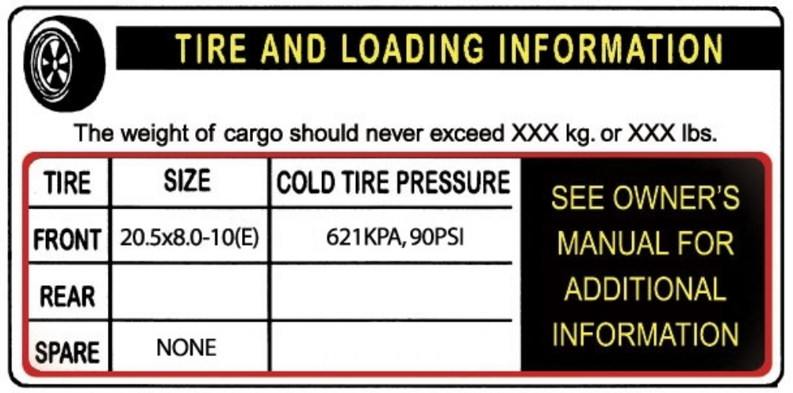
Tire and Loading Information Placard – Figure 1-1

2.2. TRAILERS 10,000 POUNDS GVWR OR LESS
1. Locate the statement, “The weight of cargo should never exceed XXX kg or XXX lbs.,” on your vehicles
placard. See figure 1-1.
2. This figure equals the available amount of cargo and luggage load capacity.
3. Determine the combined weight of luggage and cargo being loaded on the vehicle. That weight may not
safely exceed the available cargo and luggage load capacity.
The trailer’s placard refers to the Tire Information Placard attached adjacent to or near the trailer’s VIN
(Certification) label at the left front of the trailer.
18
Tire Safety Information

Note: The following calculations in Sections 2.1. and 2.2 are not required by the government. For the
purpose of completeness, NATM has included these statements.

2.3. TRAILERS OVER 10,000 POUNDS GVWR (NOTE: THESE TRAILERS ARE NOT REQUIRED TO HAVE A TIRE
INFORMATION PLACARD ON THE VEHICLE)
1. Determine the empty weight of your trailer by weighing the trailer using a public scale or other means. This
step does not have to be repeated.
2. Locate the GVWR (Gross Vehicle Weight Rating) of the trailer on your trailer’s VIN (Certification) label.
3. Subtract the empty weight of your trailer from the GVWR stated on the VIN label. That weight is the
maximum available cargo capacity of the trailer and may not be safely exceeded.

2.4. STEPS FOR DETERMINING CORRECT LOAD LIMIT – TOW VEHICLE
1. Locate the statement, “The combined weight of occupants and cargo should never exceed XXX lbs.,” on
your vehicle’s placard.
2. Determine the combined weight of the driver and passengers who will be riding in your vehicle.
3. Subtract the combined weight of the driver and passengers from XXX kilograms or XXX pounds.
4. The resulting figure equals the available amount of cargo and luggage capacity. For example, if the “XXX”
amount equals 1400 lbs. and there will be five 150 lb. passengers in your vehicle, the amount of available
cargo and luggage capacity is 650 lbs. (1400-750 (5 x 150) = 650 lbs.).
5. Determine the combined weight of luggage and cargo being loaded on the vehicle. That weight may not
safely exceed the available cargo and luggage capacity calculated in Step # 4.
6. If your vehicle will be towing a trailer, load from your trailer will be transferred to your vehicle. Consult the
tow vehicle’s manual to determine how this weight transfer reduces the available cargo and luggage
capacity of your vehicle.

2.5. GLOSSARY OF TIRE TERMINOLOGY
Accessory weight
The combined weight (in excess of those standard items which may be replaced) of automatic transmission,
power steering, power brakes, power windows, power seats, radio and heater, to the extent that these items
are available as factory-installed equipment (whether installed or not).

Bead
The part of the tire that is made of steel wires, wrapped or reinforced by ply cords and that is shaped to fit the
rim.

Bead separation
This is the breakdown of the bond between components in the bead.

Bias ply tire
A pneumatic tire in which the ply cords that extend to the beads are laid at alternate angles substantially less
than 90 degrees to the centerline of the tread.

Carcass
The tire structure, except tread and sidewall rubber which, when inflated, bears the load.

Chunking
The breaking away of pieces of the tread or sidewall.

Cold inflation pressure
The pressure in the tire before you drive.

19
Tire Safety Information

Cord
The strands forming the plies in the tire.

Cord separation
The parting of cords from adjacent rubber compounds.

Cracking
Any parting within the tread, sidewall, or inner liner of the tire extending to cord material.

CT
A pneumatic tire with an inverted flange tire and rim system in which the rim is designed with rim flanges
pointed radially inward and the tire is designed to fit on the underside of the rim in a manner that encloses the
rim flanges inside the air cavity of the tire.

Curb weight
The weight of a motor vehicle with standard equipment including the maximum capacity of fuel, oil, and coolant,
and, if so equipped, air conditioning and additional weight optional engine.

Extra load tire
A tire designed to operate at higher loads and at higher inflation pressures than the corresponding standard
tire.

Groove
The space between two adjacent tread ribs.

Innerliner
The layer(s) forming the inside surface of a tubeless tire that contains the inflating medium within the tire.

Innerliner separation
The parting of the innerliner from cord material in the carcass.

Intended outboard sidewall
The sidewall that contains a white-wall, bears white lettering or bears manufacturer, brand, and/or model name
molding that is higher or deeper than the same molding on the other sidewall of the tire or the outward facing
sidewall of an asymmetrical tire that has a particular side that must always face outward when mounted on a
vehicle.

Light truck (LT) tire
A tire designated by its manufacturer as primarily intended for use on lightweight trucks or multipurpose
passenger vehicles.

Load rating
The maximum load that a tire is rated to carry for a given inflation pressure.

Maximum load rating
The load rating for a tire at the maximum permissible inflation pressure for that tire.

Maximum permissible inflation pressure
The maximum cold inflation pressure to which a tire may be inflated.

Maximum loaded vehicle weight
The sum of curb weight, accessory weight, vehicle capacity weight, and production options weight.

Measuring rim
The rim on which a tire is fitted for physical dimension requirements.

20
Tire Safety Information

Non-pneumatic rim
A mechanical device which, when a non-pneumatic tire assembly incorporates a wheel, supports the tire, and
attaches, either integrally or separably, to the wheel center member and upon which the tire is attached.

Non-pneumatic spare tire assembly
A non-pneumatic tire assembly intended for temporary use in place of one of the pneumatic tires and rims that
are fitted to a passenger car in compliance with the requirements of this standard.

Non-pneumatic tire
A mechanical device which transmits, either directly or through a wheel or wheel center member, the vertical
load and tractive forces from the roadway to the vehicle, generates the tractive forces that provide the
directional control of the vehicle and does not rely on the containment of any gas or fluid for providing those
functions.

Non-pneumatic tire assembly
A non-pneumatic tire, alone or in combination with a wheel or wheel center member, which can be mounted on
a vehicle.

Normal occupant weight
This means 68 kilograms (150 lbs.) times the number of occupants.

Occupant distribution
The distribution of occupants in a vehicle.

Open splice
Any parting at any junction of tread, sidewall, or innerliner that extends to cord material.

Outer diameter
The overall diameter of an inflated new tire.

Overall width
The linear distance between the exteriors of the sidewalls of an inflated tire, including elevations due to
labeling, decorations, or protective bands or ribs.

Ply
A layer of rubber-coated parallel cords.

Ply separation
A parting of rubber compound between adjacent plies.

Pneumatic tire
A mechanical device made of rubber, chemicals, fabric and steel or other materials, that, when mounted on an
automotive wheel, provides the traction and contains the gas or fluid that sustains the load.

Production options weight
The combined weight of those installed regular production options weighing over 2.3 kilograms (5 lbs.) in
excess of those standard items which they replace, not previously considered in curb weight or accessory
weight, including heavy duty brakes, ride levelers, roof rack, heavy duty battery, and special trim.

Radial ply tire
A pneumatic tire in which the ply cords that extend to the beads are laid at substantially 90 degrees to the
centerline of the tread.

Recommended inflation pressure
This is the inflation pressure provided by the vehicle manufacturer on the Tire Information label and on the
Certification / VIN tag.

21
Tire Safety Information

Reinforced tire
A tire designed to operate at higher loads and at higher inflation pressures than the corresponding standard
tire.

Rim
A metal support for a tire or a tire and tube assembly upon which the tire beads are seated.

Rim diameter
This means the nominal diameter of the bead seat.

Rim size designation
This means the rim diameter and width.

Rim type designation
This means the industry of manufacturer’s designation for a rim by style or code.

Rim width
This means the nominal distance between rim flanges.

Section width
The linear distance between the exteriors of the sidewalls of an inflated tire, excluding elevations due to
labeling, decoration, or protective bands.

Sidewall
That portion of a tire between the tread and bead.

Sidewall separation
The parting of the rubber compound from the cord material in the sidewall.

Special Trailer (ST) tire
The "ST" is an indication the tire is for trailer use only.

Test rim
The rim on which a tire is fitted for testing, and may be any rim listed as appropriate for use with that tire.

Tread
That portion of a tire that comes into contact with the road.

Tread rib
A tread section running circumferentially around a tire.

Tread separation
Pulling away of the tread from the tire carcass.

Treadwear indicators (TWI)
The projections within the principal grooves designed to give a visual indication of the degrees of wear of the
tread.

Vehicle capacity weight
The rated cargo and luggage load plus 68 kilograms (150 lbs.) times the vehicle’s designated seating capacity.

Vehicle maximum load on the tire
The load on an individual tire that is determined by distributing to each axle its share of the maximum loaded
vehicle weight and dividing by two.

22
Tire Safety Information

Vehicle normal load on the tire
The load on an individual tire that is determined by distributing to each axle its share of the curb weight,
accessory weight, and normal occupant weight and dividing by 2.

Weather side
The surface area of the rim not covered by the inflated tire.

Wheel center member
In the case of a non-pneumatic tire assembly incorporating a wheel, a mechanical device which attaches, either
integrally or separably, to the non-pneumatic rim and provides the connection between the non-pneumatic rim
and the vehicle; or, in the case of a non-pneumatic tire assembly not incorporating a wheel, a mechanical
device which attaches, either integrally or separably, to the non-pneumatic tire and provides the connection
between tire and the vehicle.

Wheel-holding fixture
The fixture used to hold the wheel and tire assembly securely during testing.

2.6. TIRE SAFETY - EVERYTHING RIDES ON IT
The National Traffic Safety Administration (NHTSA) has published a brochure (DOT HS 809 361) that
discusses all aspects of Tire Safety, as required by CFR 575.6. This brochure is reproduced in part below. It
can be obtained and downloaded from NHTSA, free of charge, from the following web site:

http://www.nhtsa.dot.gov/cars/rules/TireSafety/ridesonit/tires_index.html

Studies of tire safety show that maintaining proper tire pressure, observing tire and vehicle load limits (not
carrying more weight in your vehicle than your tires or vehicle can safely handle), avoiding road hazards, and
inspecting tires for cuts, slashes, and other irregularities are the most important things you can do to avoid tire
failure, such as tread separation or blowout and flat tires. These actions, along with other care and
maintenance activities, can also:

• Improve vehicle handling
• Help protect you and others from avoidable breakdowns and accidents
• Improve fuel economy
• Increase the life of your tires.

This booklet presents a comprehensive overview of tire safety, including information on the following topics:

• Basic tire maintenance
• Uniform Tire Quality Grading System
• Fundamental characteristics of tires
• Tire safety tips.

Use this information to make tire safety a regular part of your vehicle maintenance routine. Recognize that the
time you spend is minimal compared with the inconvenience and safety consequences of a flat tire or other tire
failure.

2.7. SAFETY FIRST–BASIC TIRE MAINTENANCE
Properly maintained tires improve the steering, stopping, traction, and load-carrying capability of your vehicle.
Underinflated tires and overloaded vehicles are a major cause of tire failure. Therefore, as mentioned above, to
avoid flat tires and other types of tire failure, you should maintain proper tire pressure, observe tire and vehicle
load limits, avoid road hazards, and regularly inspect your tires.

2.8. FINDING YOUR VEHICLE'S RECOMMENDED TIRE PRESSURE & LOAD LIMITS
Tire information placards and vehicle certification labels contain information on tires and load limits. These
labels indicate the vehicle manufacturer's information including:

• Recommended tire size

23
Tire Safety Information

• Recommended tire inflation pressure
• Vehicle capacity weight (VCW–the maximum occupant and cargo weight a vehicle is designed to carry)
• Front and rear gross axle weight ratings (GAWR– the maximum weight the axle systems are designed to
carry).

Both placards and certification labels are permanently attached to the trailer near the left front.

2.9. UNDERSTANDING TIRE PRESSURE & LOAD LIMITS
Tire inflation pressure is the level of air in the tire that provides it with load-carrying capacity and affects the
overall performance of the vehicle. The tire inflation pressure is a number that indicates the amount of air
pressure– measured in pounds per square inch (psi)–a tire requires to be properly inflated. (You will also find
this number on the vehicle information placard expressed in kilopascals (kPa), which is the metric measure
used internationally.)

Manufacturers of passenger vehicles and light trucks determine this number based on the vehicle's design load
limit, that is, the greatest amount of weight a vehicle can safely carry and the vehicle's tire size. The proper tire
pressure for your vehicle is referred to as the "recommended cold inflation pressure." (As you will read below, it
is difficult to obtain the recommended tire pressure if your tires are not cold.) Because tires are designed to be used on more than one type of vehicle, tire manufacturers list the "maximum permissible inflation pressure" on the tire sidewall. This number is the greatest amount of air pressure that should ever be put in the tire under normal driving conditions.

2.10. CHECKING TIRE PRESSURE
It is important to check your vehicle's tire pressure at least once a month for the following reasons:

• Most tires may naturally lose air over time.
• Tires can lose air suddenly if you drive over a pothole or other object or if you strike the curb when
parking.
• With radial tires, it is usually not possible to determine under inflation by visual inspection.

For convenience, purchase a tire pressure gauge to keep in your vehicle. Gauges can be purchased at tire
dealerships, auto supply stores, and other retail outlets.
The recommended tire inflation pressure that vehicle manufacturers provide reflects the proper psi when a tire
is cold. The term cold does not relate to the outside temperature. Rather, a cold tire is one that has not been
driven on for at least three hours. When you drive, your tires get warmer, causing the air pressure within them
to increase. Therefore, to get an accurate tire pressure reading, you must measure tire pressure when the tires
are cold or compensate for the extra pressure in warm tires.

2.11. STEPS FOR MAINTAINING PROPER TIRE PRESSURE
• Step 1: Locate the recommended tire pressure on the vehicle's tire information placard, certification
label, or in the owner's manual.
• Step 2: Record the tire pressure of all tires.
• Step 3: If the tire pressure is too high in any of the tires, slowly release air by gently pressing on the tire
valve stem with the edge of your tire gauge until you get to the correct pressure.
• Step 4: If the tire pressure is too low, note the difference between the measured tire pressure and the
correct tire pressure. These "missing" pounds of pressure are what you will need to add.
• Step 5: At a service station, add the missing pounds of air pressure to each tire that is underinflated.
• Step 6: Check all the tires to make sure they have the same air pressure (except in cases in which the
front and rear tires are supposed to have different amounts of pressure).

If you have been driving your vehicle and think that a tire is underinflated, fill it to the recommended cold
inflation pressure indicated on your vehicle's tire information placard or certification label. While your tire may
still be slightly underinflated due to the extra pounds of pressure in the warm tire, it is safer to drive with air
pressure that is slightly lower than the vehicle manufacturer's recommended cold inflation pressure than to
drive with a significantly underinflated tire. Since this is a temporary fix, don't forget to recheck and adjust the
tire's pressure when you can obtain a cold reading.

24
Tire Safety Information

2.12. TIRE SIZE
To maintain tire safety, purchase new tires that are the same size as the vehicle's original tires or another size
recommended by the manufacturer. Look at the tire information placard, the owner's manual, or the sidewall of
the tire you are replacing to find this information. If you have any doubt about the correct size to choose,
consult with the tire dealer.

2.13. TIRE TREAD
The tire tread provides the gripping action and traction that prevent your vehicle from slipping or sliding,
especially when the road is wet or icy. In general, tires are not safe and should be replaced when the tread is
worn down to 1/16 of an inch. Tires have built-in tread wear indicators that let you know when it is time to
replace your tires. These indicators are raised sections spaced intermittently in the bottom of the tread grooves.
When they appear "even" with the outside of the tread, it is time to replace your tires. Another method for
checking tread depth is to place a penny in the tread with Lincoln's head upside down and facing you. If you
can see the top of Lincoln's head, you are ready for new tires.

2.14. TIRE BALANCE & WHEEL ALIGNMENT
To avoid vibration or shaking of the vehicle when a tire rotates, the tire must be properly balanced. This
balance is achieved by positioning weights on the wheel to counterbalance heavy spots on the wheel-and-tire
assembly. A wheel alignment adjusts the angles of the wheels so that they are positioned correctly relative to
the vehicle's frame. This adjustment maximizes the life of your tires. These adjustments require special
equipment and should be performed by a qualified technician.

2.15. TIRE REPAIR
The proper repair of a punctured tire requires a plug for the hole and a patch for the area inside the tire that
surrounds the puncture hole. Punctures through the tread can be repaired if they are not too large, but
punctures to the sidewall should not be repaired. Tires must be removed from the rim to be properly inspected
before being plugged and patched.

2.16. TIRE FUNDAMENTALS
Federal law requires tire manufacturers to place standardized information on the sidewall of all tires. This
information identifies and describes the fundamental characteristics of the tire and also provides a tire
identification number for safety standard certification and in case of a recall.

2.17 INFORMATION ON PASSENGER VEHICLE TIRES
Please refer to the diagram below.
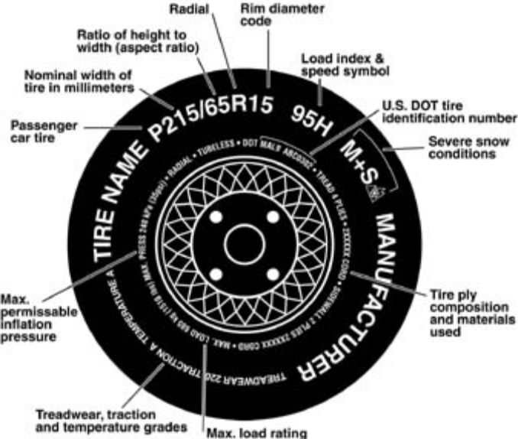

25
Tire Safety Information

P
The "P" indicates the tire is for passenger vehicles.

Next number
This three-digit number gives the width in millimeters of the tire from sidewall edge to sidewall edge. In general,
the larger the number, the wider the tire.

Next number
This two-digit number, known as the aspect ratio, gives the tire's ratio of height to width. Numbers of 70 or
lower indicate a short sidewall for improved steering response and better overall handling on dry pavement.

R
The "R" stands for radial. Radial ply construction of tires has been the industry standard for the past 20 years.

Next number
This two-digit number is the wheel or rim diameter in inches. If you change your wheel size, you will have to
purchase new tires to match the new wheel diameter.

Next number
This two- or three-digit number is the tire's load index. It is a measurement of how much weight each tire can
support. You may find this information in your owner's manual. If not, contact a local tire dealer. Note: You may
not find this information on all tires because it is not required by law.

M+S
The "M+S" or "M/S" indicates that the tire has some mud and snow capability. Most radial tires have these
markings; hence, they have some mud and snow capability.

Speed Rating
The speed rating denotes the speed at which a tire is designed to be driven for extended periods of time. The
ratings range from 99 miles per hour (mph) to 186 mph. These ratings are listed below. Note: You may not find
this information on all tires because it is not required by law.

26
Tire Safety Information

Letter Rating - Speed Rating
Q | 99 mph
R | 106 mph
S | 112 mph
T | 118 mph
U | 124 mph
H | 130 mph
V | 149 mph
W | 168* mph
Y | 186* mph

* For tires with a maximum speed capability over 149 mph, tire manufacturers sometimes use the letters ZR.
For those with a maximum speed capability over 186 mph, tire manufacturers always use the letters ZR.

U.S. DOT Tire Identification Number
This begins with the letters "DOT" and indicates that the tire meets all federal standards. The next two numbers
or letters are the plant code where it was manufactured, and the last four numbers represent the week and year
the tire was built. For example, the numbers 3197 means the 31st week of 1997. The other numbers are
marketing codes used at the manufacturer's discretion. This information is used to contact consumers if a tire
defect requires a recall.

Tire Ply Composition and Materials Used
The number of plies indicates the number of layers of rubber-coated fabric in the tire. In general, the greater the
number of plies, the more weight a tire can support. Tire manufacturers also must indicate the materials in the
tire, which include steel, nylon, polyester, and others.

Maximum Load Rating
This number indicates the maximum load in kilograms and pounds that can be carried by the tire.

Maximum Permissible Inflation Pressure
This number is the greatest amount of air pressure that should ever be put in the tire under normal driving
conditions.

2.18. UTQGS INFORMATION
Treadwear Number
This number indicates the tire's wear rate. The higher the tread wear number is, the longer it should take for the
tread to wear down. For example, a tire graded 400 should last twice as long as a tire graded 200.

Traction Letter
This letter indicates a tire's ability to stop on wet pavement. A higher graded tire should allow you to stop your
car on wet roads in a shorter distance than a tire with a lower grade. Traction is graded from highest to lowest
as "AA","A", "B", and "C".

Temperature Letter
This letter indicates a tire's resistance to heat. The temperature grade is for a tire that is inflated properly and
not overloaded. Excessive speed, under inflation or excessive loading, either separately or in combination, can
cause heat build-up and possible tire failure. From highest to lowest, a tire's resistance to heat is graded as "A",
"B", or "C".

27
Tire Safety Information

2.19. ADDITIONAL INFORMATION ON LIGHT TRUCK TIRES
Please refer to the following diagram.
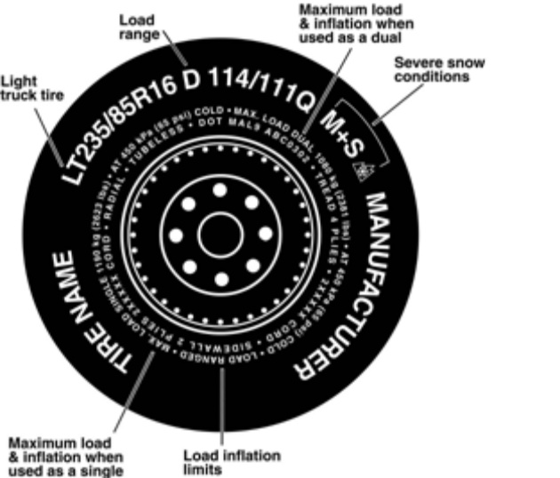

Tires for light trucks have other markings besides those found on the sidewalls of passenger tires.

LT
The "LT" indicates the tire is for light trucks or trailers.

ST
An "ST" is an indication the tire is for trailer use only.

Max. Load Dual kg (lbs) at kPa (psi) Cold
This information indicates the maximum load and tire pressure when the tire is used as a dual, that is, when
four tires are put on each rear axle (a total of six or more tires on the vehicle).

Max. Load Single kg (lbs) at kPa (psi) Cold
This information indicates the maximum load and tire pressure when the tire is used as a single.

Load Range
This information identifies the tire's load-carrying capabilities and its inflation limits.

2.20. TIRE SAFETY TIPS
Preventing Tire Damage

• Slow down if you have to go over a pothole or other object in the road.
• Do not run over curbs or other foreign objects in the roadway, and try not to strike the curb when parking.

Tire Safety Checklist

• Check tire pressure regularly (at least once a month), including the spare.
• Inspect tires for uneven wear patterns on the tread, cracks, foreign objects, or other signs of wear or
trauma.
• Remove bits of glass and foreign objects wedged in the tread.
• Make sure your tire valves have valve caps.
• Check tire pressure before going on a long trip.
• Do not overload your vehicle. Check the Tire Information and Loading Placard or User’s Manual for the
maximum recommended load for the vehicle.

28
Coupling to the Tow Vehicle

3. COUPLING TO THE TOW VEHICLE

Follow all of the safety precautions and instructions in this manual to ensure safety of persons, cargo, and
satisfactory life of the trailer.

3.1 USE AN ADEQUATE TOW VEHICLE & HITCH
If the vehicle or hitch is not properly selected and matched to the Gross Vehicle Weight Rating (GVWR) of your
trailer, you can cause an accident that could lead to death or serious injury. If you already have a tow vehicle,
know your vehicle tow rating, and Gross Combination Weight Rating (GCWR) and make certain the trailer’s
rated capacity is less than or equal to the tow vehicle’s rated towing capacity. If you already have (or plan to
buy) a trailer, make certain that the tow rating of the tow vehicle is equal to or greater than the GVWR of the
trailer, and that the GCWR will be within limits.

^ DANGER
Use of a hitch with a load rating less than the
load rating of the trailer can result in loss of
control and may lead to death or serious injury.

Use of a tow vehicle with a towing capacity
less than the load rating of the trailer can result in loss of control, and may lead to death or serious injury.

Be sure your hitch and tow vehicle are rated
for the Gross Vehicle Weight Rating of your
trailer.

29
Coupling to the Tow Vehicle

3.2. TRAILER INFORMATION
Certification / VIN Label

The location of the trailers “Certification / VIN
Tag” is shown below.

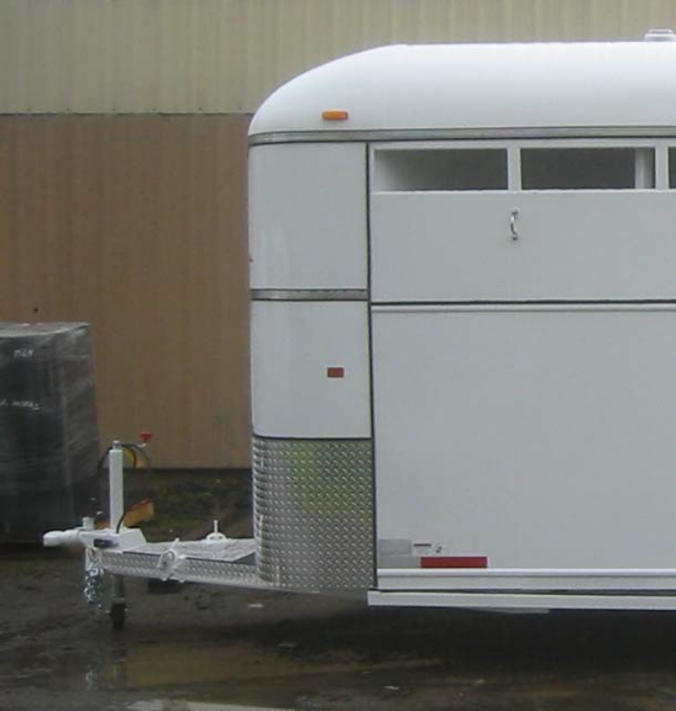

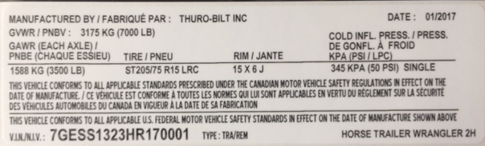

The trailer Certification / VIN tag contains the following critical safety information for the use of
your trailer:

• MANUFACTURER: Name of trailer manufacturer

• DATE OF MANUFACTURE: Month and year the trailer was manufactured.

• GVWR: The Gross Vehicle Weight Rating is the maximum allowable gross weight of the
trailer and its contents. The gross weight of the trailer includes the weight of the trailer and all
of the items within it (such as cargo, water, food and other supplies).

30
Coupling to the Tow Vehicle

• GAWR: The Gross Axle Weight Rating is the maximum gross weight that an axle can
support. It is the lowest of axle, wheel, or tire rating. Sometimes the tire or wheel rating is
lower than the axle manufacturers rating, and will then determine GAWR.
The sum total of the GAWR for all trailer axles may be less than the GVWR for the trailer,
because some of the trailer load is carried by the tow vehicle, rather than by the trailer axle(s).
The total weight of the cargo and trailer must not exceed the GVWR, and the load on an axle
must not exceed its GAWR.

• TIRE SIZE: The tire size recommended for your trailer and load range.

• PSIC: The “pounds per square inch- cold” is the tire pressure (Kilopascals / Pounds per
Square Inch) measured when Cold.

• CERTIFICATION STATEMENT: “This trailer meets all the Federal Motor Vehicle Safety
Standards in effect on the date of manufacture shown above”.

• VIN: The Vehicle Identification Number.

• VEHICLE TYPE: Generally the word “trailer” is used. However, after this you may put a
Model #, or additional descriptor.

• Tow Vehicle: When equipping a new vehicle or an older vehicle to tow your trailer, ask the
vehicle dealer for advice on how to outfit the towing vehicle. Discuss the following information
and equipment with the vehicle dealer.

• Overall Carrying and Towing Capacity of Vehicle: Vehicle manufacturers will provide you
with the maximum towing capacities of their various models, as well as the GCWR. No
amount of reinforcement will give a 100 horsepower, 2,500 pound truck the towing capacity
that a 300 horsepower, 5,000 pound truck has.

• Towing Hitch: The towing hitch attached to your tow vehicle must have a capacity equal to or
greater than the load rating of the trailer you intend to tow. The hitch capacity must also be
matched to the tow vehicle capacity.

• Suspension System: A tow vehicle equipped with a factory installed “Towing Package” likely
comes equipped with heavy duty springs, heavy duty tires and other suspension components
which are able to serve the size and weight of the trailer that the vehicle is rated to tow.
However, the addition of additional equipment may further improve the tow vehicle
performance. These may include adjustable air shocks, helper springs, etc.

• Brake Controller: The brake controller is part of the tow vehicle and is essential in the
operation of the electric brakes on the trailer. If your trailer has electric brakes it requires a
brake controller be installed at the driver’s position. The brake controller is not the same as
the safety breakaway brake system that is installed on the trailer.

• Side View Mirrors: The size of the trailer that is being towed and your state law regulations
determine the size of the mirrors. However, some states prohibit extended mirrors on a tow
vehicle, except while a trailer is actually being towed. In this situation, detachable extended
mirrors are necessary. Check with your dealer or the appropriate state agency for mirror
requirements.

• Heavy Duty Flasher: A Heavy Duty Flasher is an electrical component that may be required
when your trailer turn signal lights are attached to the tow vehicle flasher circuit.

31
Coupling to the Tow Vehicle

• Electrical Connector: An Electrical Connector connects the light and brake systems on the
trailer to the light and brake controls on the towing vehicle.

• Heavy Duty Engine Oil Cooling System: The tow vehicle engine works harder when a trailer
is being towed. Depending on the size of the trailer, you may need to install a separate
engine oil cooler. Inadequate cooling may result in sudden engine failure. Ask the tow
vehicle dealer if it is necessary to install a heavy duty cooling system.

• Automatic Transmission Oil Cooler: The automatic transmission of a towing vehicle
handles more power when a trailer is being towed. Inadequate cooling will shorten
transmission life, and may result in sudden transmission failure. Ask the tow vehicle dealer if
it is necessary to install a separate oil cooler for the automatic transmission.

• Fire Extinguisher: It is sensible to have a fire extinguisher in the tow vehicle.

• Emergency Flares and Emergency Triangle Reflectors: It is wise to carry these warning
devices even if you are not towing a trailer. It is particularly important to have these when
towing a trailer because the hazard flashers of your towing vehicle will not operate for as long
a period of time when the battery is running both the trailer lights and tow vehicle lights.

3.3 COUPLING & UNCOUPLING THE TRAILER
A secure coupling (or fastening) of the trailer to the tow vehicle is essential. A loss of coupling
may result in death or serious injury. Therefore, you must understand and follow all of the
instructions for coupling.

The following parts are involved in making a secure coupling between the trailer and tow vehicle:

Coupling: That part of the trailer connecting mechanism by which the connection is actually
made to the trailer hitch. This does not include any structural member, extension of the trailer
frame, or brake controller.

Hitch: That part of the connecting mechanism including the ball support platform and ball and
those components that extend and are attached to the towing vehicle, including bumpers intended
to serve as hitches.)

• Weight Distributing Hitch (or Equalizing Hitch): A mechanical device that connects
the trailer to the towing vehicle and by means of leverage applied on both the trailer and
towing vehicle structures, when properly adjusted, distributes the imposed vertical load at
the hitch and coupling connection between structures of the towing vehicle and trailer.

• Weight Carrying Hitch: A mechanical and/or structural device that connects the trailer to
the towing vehicle and that does not employ features designed to redistribute the load
imposed at the hitch and carrying connection.

Safety chains or cables: Chains or cables permanently attached to the trailer such that if the
coupler connection comes loose, the safety chains or cables can keep the trailer attached to the
tow vehicle. With properly rigged safety chains or cables, it is possible to keep the tongue of the
trailer from digging into the road pavement, even if the coupler-to-hitch connection comes apart.
Some states do not allow safety cables, e.g. Pennsylvania; therefore it may be wise to check with
the State Police to see if your state has any restrictions on the use of safety cables, if your trailer
is so equipped.

Trailer lighting (and braking) connector: A device that connects electrical power from the tow
vehicle to the trailer. Electricity is used to turn on brake lights, running lights, and turn signals as

32
Coupling to the Tow Vehicle

required. In addition, if your trailer has a separate braking system, the electrical connector will
also supply power to the trailer brakes from the tow vehicle.

Breakaway switch: If the trailer becomes de-coupled from the towing vehicle, the breakaway
switch lanyard, attached independently to the tow vehicle hitch, will pull a pin in the emergency
electrical break-away switch on the trailer. The breakaway switch is activated by a separate
battery supply in the trailer such as to energize the trailer brakes independently of the towing
vehicle. It is important to check the state of charge of the emergency break-away battery before
each trip. Simply pull the pin out of the switch by hand and then try to pull the trailer. If you feel a
significant drag force the brakes are activated. Be sure to re-insert the pin in the break-away
switch. Also be sure to allow enough slack in the break-away brake lanyard such that the switch
will only activate (pin pulls out) if the coupler connection comes loose.

Jack: A device on the trailer that is used to raise and lower the trailer tongue. On larger trailers
the jack is sometimes called the “landing gear.”
^

^WARNING
An improperly coupled trailer can result in
death or serious injury.

Do not move the trailer until:
• The coupler is secured and locked to hitch;
• The safety chains are secured to the tow
vehicle; and
• The trailer jack(s) are fully retracted.

Do not tow the trailer on the road until:
• Tires and wheels are checked;
• The trailer brakes are checked;
• The breakaway switch is connected to the
tow vehicle, and the break-away battery is
checked.
• The load is secured to the trailer; and
• The trailer lights are connected and
checked.

3.4. VARIOUS COUPLER DESIGNS
Trailers are produced with a variety of coupler devices. One of the sections below will pertain to
your trailer.

Bumper pull (Ball Hitch) Coupler
Gooseneck Hitch Coupler

If the coupler on your trailer does not resemble one of the couplers shown in the figures, see the
separate coupler instructions. If you do not have separate coupler instructions, call Thuro-Bilt, Inc. at 541-670-8701
for a free copy.

33
Coupling to the Tow Vehicle

3.5. TRAILER WITH BALL-HITCH COUPLER
A ball hitch coupler connects to a ball that is located on or under the rear bumper of tow vehicle.
This system of coupling a trailer to a tow vehicle is sometimes referred to as “bumper pull.”

A ball hitch trailer may be fitted with a tongue jack that can raise and lower the coupler. The
tongue jack is mounted to the A-frame (front, or tongue) part of the trailer. By rotating the jack
handle clockwise, the jack will extend and raise the tongue of the trailer.

Trailer with Ball-hitch Coupler Pictured Below
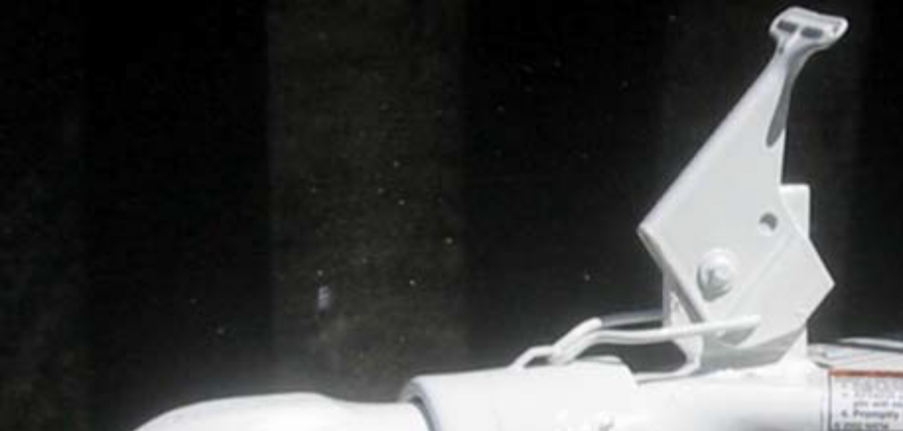
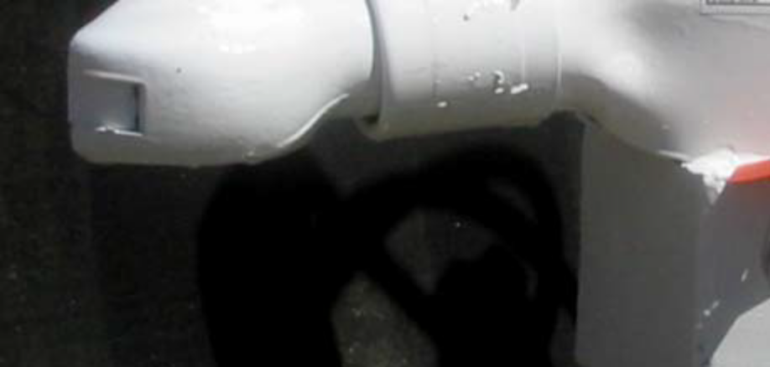

Be sure the Ball Hitch coupler is suitable for the size and weight of the trailer. The load rating of
the coupler and the necessary ball size are listed on the trailer tongue. You must provide a hitch
and ball for your tow vehicle, where the load rating of the hitch and ball is equal to or greater than
that of your trailer. Also, the ball size must be the same as the coupler size. If the hitch ball is too
small, too large, is underrated, is loose or is worn, the trailer can come loose from the tow vehicle,
and may cause death or serious injury.

THE TOW VEHICLE, HITCH AND BALL MUST HAVE A RATED TOWING CAPACITY EQUAL
TO OR GREATER THAN THE TRAILER GROSS VEHICLE WEIGHT RATING (GVWR).

IT IS ESSENTIAL THAT THE HITCH BALL BE OF THE SAME SIZE AS THE COUPLER.

The ball size and load rating (capacity) are marked on the ball; hitch capacity is marked on the
hitch.

3.6. BEFORE COUPLING THE TRAILER TO THE TOW VEHICLE
Be sure the size and rating of hitch ball match the size and rating of the coupler. Hitch balls and
couplers are marked with their size and rating.

34

Coupling to the Tow Vehicle
^

^WARNING
Coupler-to-hitch mismatch can result in
uncoupling, leading to death or serious injury.

Be sure the LOAD RATING of the hitch ball is
equal or greater than the load rating of the
coupler.

Be sure the SIZE of the hitch ball matches the
size of the coupler.

Wipe the hitch ball clean and inspect it visually and by feel for flat spots, cracks and pits.

^WARNING
A worn, cracked or corroded hitch ball can fail
while towing, and may result in death or
serious injury.

Before coupling trailer, inspect the hitch ball for wear, corrosion and cracks.

Replace worn or damaged hitch ball.

Rock the ball to make sure it is tight to the hitch, and visually check that the hitch ball nut is
solid against the lock washer and hitch frame.

Wipe the inside and outside of the coupler clean and inspect it visually for cracks and
deformations; feel the inside of the coupler for worn spots and pits.

Be sure the coupler is tight to the tongue of the trailer. All coupler fasteners must be visibly
solid against the trailer frame.

^WARNING
A loose hitch-ball nut can result in uncoupling,
leading to death or serious injury.

Be sure the hitch ball is tight to the hitch before coupling the trailer.

Raise the bottom surface of the coupler to be above the top of the hitch ball. Use the jack if
one is provided; otherwise, use wood or concrete blocks to support the trailer tongue.

3.7. PREPARE THE COUPLER & HITCH
Lubricate the hitch ball and the inside of the coupler with a thin layer of automotive bearing
grease. If your trailer is equipped with a jack, raise the coupler above the ball height.

35
Coupling to the Tow Vehicle

Open the coupler locking mechanism. Ball couplers have a locking mechanism with an
internal moving piece (ball clamp) and an outside handle, wheel, or latch.

In the open position, the coupler is able to drop fully onto the hitch ball.
See the coupler instructions for details of placing the coupler in the “open” position.

Slowly back up the tow vehicle so that the hitch ball is near or aligned under the coupler, if the
trailer jack has raised the coupler.

Figure 3-1 Ball Hitch Coupler Engaged
Closed


Released



3.8. COUPLE THE TRAILER TO THE TOW VEHICLE
If your trailer does not have a jack, you will have to lift the coupler and place it over the ball.

If you have a jack, lower the trailer tongue until the coupler fully engages the hitch ball. If the
coupler does not line up with the hitch ball, adjust the position of the tow vehicle.

Engage the coupler locking mechanism. In the engaged position, the locking mechanism
securely holds the coupler to the hitch ball.

Insert a pin or lock through the hole in the locking mechanism.

36

Coupling to the Tow Vehicle

Be sure the coupler is all the way on the hitch ball and the locking mechanism is engaged. A
properly engaged locking mechanism will allow the coupler to raise the rear of the tow
vehicle. Using the trailer jack, test to see that you can raise the rear of the tow vehicle by
1 inch, after the coupler is locked to the hitch

Safety Chain Arrangement
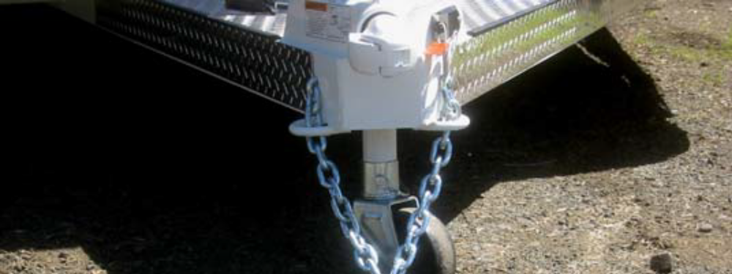
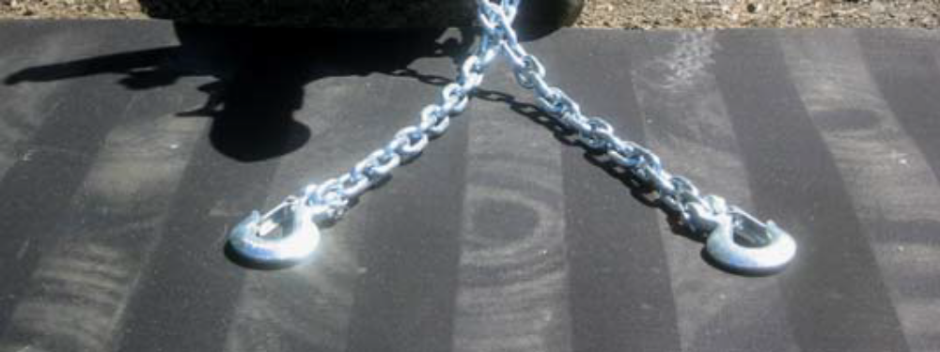

^NOTICE
Overloading can damage the tongue jack. Do
not use the tongue jack to raise the tow vehicle
more than 1 inch.

If the coupler cannot be secured to the hitch ball, do not tow the trailer. Call Thuro-Bilt, Inc. at 541-670-8701
or your dealer for assistance.

Lower the trailer so that its entire tongue weight is held by the hitch, and continue retracting
the jack to its fully retraced position.

3.9. RIG THE SAFETY CHAINS
Visually inspect the safety chains and hooks for wear or damage. Replace worn or damaged
safety chains and hooks before towing.

Rig the safety chains so that they:

Criss-cross underneath the coupler so if the trailer uncouples, the safety chains can hold
the tongue up above the road.
37

Coupling to the Tow Vehicle

Loop around a frame member of the tow vehicle or to holes provided in the hitch system
(but, do not attach them to an interchangeable part of the hitch assembly)

Attach “S” hooks up from underneath the hole (do not just drop into hole); and

Provide enough slack to permit tight turns, but not be close to the road surface to drag.
^

^WARNING
Improper rigging of the safety chains can result in loss of control of the trailer and tow vehicle, leading to death or serious injury, if the trailer uncouples from the tow vehicle.

• Fasten chains to frame of tow vehicle. Do
not fasten chains to any part of the hitch
unless the hitch has holes or loops
specifically for that purpose.

• Cross chains underneath hitch and coupler
with enough slack to permit turning and to
hold tongue up, if the trailer comes loose.

3.10. ATTACH & TEST ELECTRIC BREAKWAY SYSTEM
If the coupler or hitch fails, a properly connected and working breakaway brake system will apply
electric brakes on the trailer. The safety chains will keep the tow vehicle attached and as the
brakes are applied at the trailer’s axles, the trailer/tow vehicle combination will come to a
controlled stop.

The breakaway brake system includes a battery, a switch with a pullpin, and a lanyard. Read and
follow the instructions here as well as the instructions that have been prepared by the breakaway
brake manufacturer. If you do not have these instructions, call Thuro-Bilt, Inc. at 541-670-8701
for a free copy.

The breakaway brake system may be fitted with a “charging” capability that draws power from the
tow vehicle

38
Coupling to the Tow Vehicle

Break away Switch and Battery options Bumper Pull Trailer



Connect the pullpin lanyard to the tow vehicle so that the pullpin will be pulled out before all of
the slack in the safety chains is taken up (see Breakaway Brake System figure). Do not
connect the pullpin cable to a safety chain or to the hitch ball or hitch ball assembly. This
would keep the breakaway brake system from operating when it is needed.

To test the break-away brake battery, remove the pullpin from the switch and attempt to pull
the trailer forward. You should feel the trailer resisting being towed, but the wheels will
not necessarily be locked. If the brakes do not function, do not tow the trailer until brakes,
or battery, are repaired.

Immediately replace the pullpin. The breakaway brake system battery discharges rapidly
when the pullpin is removed.
^
^WARNING
An ineffective breakaway brake system can
result in a runaway trailer, leading to death or
serious injury, if the coupler or ball hitch fails.

Connect the breakaway cable to the tow
vehicle; and NOT to the hitch, ball or support.

Before towing the trailer, test the function of
the breakaway brake system. If the breakaway
brake system is not working, do not tow the
trailer. Have it serviced or repaired.

Do not tow the trailer with the breakaway brake system ON because the brakes will overheat
which can result in permanent brake failure.
39

Coupling to the Tow Vehicle

^WAR
^WARNING
Failure to replace the pullpin will prevent
brakes from working, leading to loss of control, serious injury or death.

If you do not use your trailer for three or more months, or during winter months:

• Store the battery indoors; and

• Charge the battery every three months.

Replace the breakaway brake battery according to the intervals specified by battery manufacturer.

40
Coupling to the Tow Vehicle

3.11. CONNECT THE ELECTRICAL CABLES
Connect the trailer lights to the tow vehicle's electrical system using the electrical connectors.

Check all lights for proper operation.

Clearance and Running Lights (Turn on tow vehicle headlights).
Brake Lights (Step on tow vehicle brake pedal).
Turn Signals (Operate tow vehicle directional signal lever).

Check electric brakes for proper operation using brake controller mounted in the cab.

If your trailer has electric brakes, your tow vehicle will have an electric brake controller that sends
power to the trailer brakes. Before towing the trailer on the road, you must operate the brake
controller while trying to pull the trailer in order to confirm that the electric brakes operate. While
towing the trailer at less than 5 m.p.h., manually operate the electric brake controller in the tow
vehicle cab. You should feel the operation of the trailer brakes.
^W

^WARNING
Improper electrical connection between the tow vehicle and the trailer will result in inoperable lights and electric brakes, and can lead to collision.

Before each tow:

• Check that the taillights, brake lights and
turn signals work

• Check that the electric brakes work by
operating the brake controller inside the tow
vehicle.

3.12. UNCOUPLING THE BALL HITCH TRAILER WITH TONGUE JACK
Follow these steps to uncouple your ball hitch trailer from the tow vehicle:

• Block trailer tires to prevent the trailer from rolling, before jacking the trailer up.
• Disconnect the electrical connector.
• Disconnect the breakaway brake switch lanyard.
• Disconnect the safety chains from the tow vehicle.
• Unlock the coupler and open it.
• Before extending jack, make certain the ground surface below the jack pad will
support the tongue load.
• Rotate the jack handle (or crank) clockwise. This will slowly extend the jack and
transfer the weight of the trailer tongue to the jack.

3.13. TRAILER WITH GOOSENECK COUPLER & DROP-LEG JACK
A gooseneck coupler on the trailer connects to a gooseneck ball that you must have installed in
the bed of the tow vehicle. This system of coupling a trailer to a tow vehicle permits the tow
vehicle to turn to sharper angles than are permitted by a bumper hitch system. A gooseneck
coupler consists of a tube in an inverted “U” shape and a gooseneck ball receiver. “Trailer with
Gooseneck Hitch Coupler” figure shows a trailer with a gooseneck coupler.

41
Coupling to the Tow Vehicle

Trailer with Gooseneck Coupler
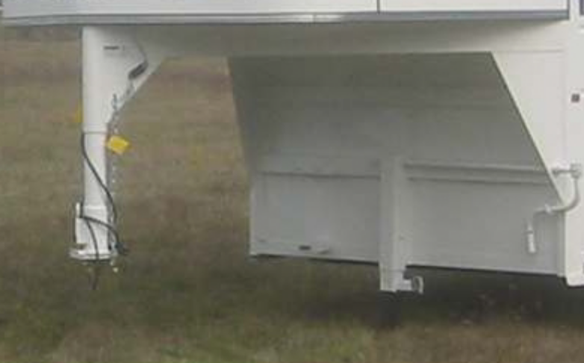

We have installed a Gooseneck ball receiver that is suitable for the size and weight of the trailer.
The load rating of the coupler and the necessary ball size are listed on the gooseneck.

You must provide a gooseneck ball and support structure that is marked with a rating that meets
or exceeds the GVWR of your trailer and matches the size of the gooseneck ball receiver. If the
gooseneck ball is too small, is underrated, is loose or is worn, the trailer can come loose from the
tow vehicle, and may lead to death or serious injury.

THE TOW VEHICLE, SUPPORT STRUCTURE AND GOOSENECK BALL MUST HAVE A
RATED TOWING CAPACITY EQUAL TO OR GREATER THAN THE TRAILER GROSS
VEHICLE WEIGHT RATING (GVWR).
IT IS ESSENTIAL THAT THE GOOSENECK BALL BE OF THE SAME SIZE AS THE
GOOSENECK BALL RECEIVER.

The ball size and load rating (capacity) are marked on the ball; hitch capacity is marked on the
hitch.
^W

^WARNING
Coupler-to-hitch mismatch can result in
uncoupling, leading to death or serious injury.

Be sure the LOAD RATING of the hitch ball is
equal or greater than the load rating of thecoupler.

Be sure the SIZE of the hitch ball matches the
size of the coupler.

42
Coupling to the Tow Vehicle

The height of the ball receiver on the trailer must be adjusted to match the height of the
gooseneck ball on your tow vehicle, so that:

There is clearance between the bottom of the trailer and the sides of the tow vehicle bed;
and
The trailer is level and allows equal weight distribution on tandem axles.

The “Gooseneck Ball Receiver and Height Adjustment” figure shows the gooseneck height
adjustment. The gooseneck height adjustment bolts, which have a “cup” that makes a gripping
impression into the gooseneck tube, must be tight so that the trailer does not drop to a lower
position. Do not over-tighten because the tube can be deformed. After tightening the bolts,
tighten the jam nuts on the bolts.

Gooseneck Ball Receiver and Height Adjustment
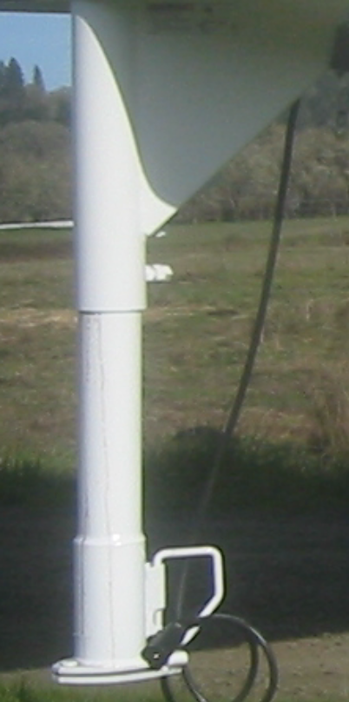

^WARNING
Improper gooseneck height adjustment can
result in overloaded tires, blowout and loss of
control, leading to death or serious injury.
Adjust the gooseneck receiver so that the
loaded trailer is level.

A trailer having a gooseneck hitch will have one or two drop leg jacks for raising and lowering the
gooseneck ball receiver. Because several drop leg jack mechanisms are available, the general
instructions below may vary slightly from the jack manufacturer’s instructions. If the trailer jack on
your trailer does not resemble the jack shown in the figures, follow the jack instructions provided
by the jack manufacturer. If you do not have these instructions, call Thuro-Bilt, Inc. at
541-670-8701 for a free copy.
43

Coupling to the Tow Vehicle

Drop-leg Jack Arrangement


Before attempting to tow the trailer:

Be sure the size and rating of the gooseneck ball match the size and rating of the receiver.
Gooseneck balls and receivers are marked with their size and ratings.

Wipe the gooseneck ball clean and inspect it visually and by feel for flat spots, cracks and
pits.

44
Coupling to the Tow Vehicle
^
^WARNING
A worn, cracked or corroded gooseneck ball
can fail while towing, and may result in death
or serious injury.

Before coupling the trailer, inspect the
gooseneck ball for wear, corrosion and cracks;
and replace worn or damaged gooseneck ball.

Rock the ball to make sure it is tight to the ball support, and visually check that the gooseneck
ball nut is solid against the lock washer and ball support frame.
^

^WARNING
A loose gooseneck ball can result in
uncoupling, leading to death or serious injury.
Be sure the gooseneck ball nut is tight before
coupling the trailer.

Wipe the inside and outside of the receiver clean and inspect it visually for cracks; and feel
the inside of the receiver for worn spots and pits. If any of these conditions exist, have the
receiver replaced before coupling the trailer.

Lubricate the inside of the gooseneck ball receiver with automotive bearing grease.
Be sure the receiver is tight to the trailer. All receiver fasteners must be visibly solid against
the trailer frame.

Release the jack handle or crank from its holder (see “Drop Leg Jack” figure).

Make certain the ground beneath the jack foot is firm enough to support the tongue weight.

Rotate the handle/crank clockwise to raise the bottom surface of the gooseneck to be above
the top of the gooseneck ball.

3.14. PREPARE THE BALL RECEIVER & GOOSENECK BALL
Release the lock plate on the gooseneck ball receiver. With the spring-loaded lock plate
locking pin in the OPEN position, rotate the lock plate to a position that allows the
gooseneck ball to enter the receiver (see “Gooseneck Ball Receiver and Height
Adjustment” figure).

Slowly back up the tow vehicle so that the gooseneck ball is aligned under the gooseneck ball
receiver.

45
Coupling to the Tow Vehicle

^W^
^WARNING
If the trailer drops during coupling, death or
serious injury may result.

There must be no one under the trailer or
coupler before or during the coupling
operation.

3.15. COUPLE THE TRAILER TO THE TOW VEHICLE
Rotate the jack handle counter-clockwise. This will retract the jack causing the gooseneck
ball receiver to drop down so it can fully engage the gooseneck ball and transfer the
weight of the trailer tongue to the towing vehicle hitch. If the receiver does not line up with
the ball, raise the receiver again and adjust the position of the tow vehicle. Then lower
the receiver over the ball. When the drop leg base is no longer resting on the ground, the
towing vehicle hitch is holding all of the weight of the trailer tongue.

Close the lock plate on the gooseneck ball receiver.

Move the spring-loaded lock plate locking pin to the CLOSED position. Be sure the locking
pin is holding the lock plate.

Be sure the receiver is all the way on the gooseneck ball and the lock plate is engaged. A
properly engaged locking mechanism will allow the coupler to raise the rear of the tow
vehicle. Using the trailer jack, test to see that you can raise the rear of the tow vehicle by
1 inch.

^NOTICE
Overloading can damage the drop leg jack. Do
not use the drop leg jack to raise the tow
vehicle more than 1 inch.

If the gooseneck ball cannot be secured to the receiver, do not tow the trailer. Call
Thuro-Bilt, Inc. at 541-670-8701 or your dealer for assistance.

After testing to see that the receiver is properly secured and locked to the ball, retract the jack
to its fully retracted position.

Return the drop legs to their upper positions. The drop legs are held in the lowered position
with a plunger pin. Rotating the plunger pin while pulling it outward will cause it to come
out of engagement with the drop leg and the leg will rapidly rise (see “Drop Leg
Mechanism” figure).

46
Coupling to the Tow Vehicle
Drop Leg Mechanism

^ CAUTION
The drop legs are heavily spring loaded in the
Lowered position. They will rapidly return to the upper position when released and can inflict serious bruises, scrapes or pinching.

Keep your feet, shins and hands well clear of
the drop legs and drop leg bases when
releasing the drop legs.

Always wear shoes or boots while performing
this operation.

3.16. RIG THE SAFETY CHAINS
Visually inspect the safety chains and hooks for wear or damage. Replace worn or damaged
safety chains and hooks before towing.

Rig the safety chains so that they attach to the “safety chain receivers” in the bed of the
truck. If you are not certain of the hitch provisions for receiving safety chains, contact the
hitch manufacturer or installer. Do NOT attach the safety chains to the gooseneck ball or
its support; and

47
Coupling to the Tow Vehicle

Rig the safety chains so they have sufficient slack to permit turning, but not too much
slack – the safety chains must keep the gooseneck on the tow vehicle bed if the trailer
uncouples.
^WARNING
Improper rigging of the safety chains can result in loss of control of the trailer and tow vehicle, leading to death or serious injury, if the trailer uncouples from the tow vehicle.

• Fasten chains to safety chain receivers on
the hitch, not to ball.

• Have sufficient slack to permit turning and
to keep gooseneck on bed of tow vehicle,
if the trailer comes loose.

3.17. ATTACH & TEST THE BREAKAWAY BRAKE SYSTEM
If the coupler or hitch fails, a properly connected and working breakaway brake system will apply
electric brakes on the trailer. The safety chains will keep the tow vehicle attached and as the
brakes are applied at the trailer’s axles, the trailer/tow vehicle combination will come to a
controlled stop.

The breakaway brake system includes a battery, a switch with a pullpin, and a breakaway brake
controller. Read and follow the instructions here as well as the instructions that have been
prepared by the breakaway brake controller manufacturer. If you do not have these instructions,
call Thuro-Bilt, Inc. at 541-670-8701 for a free copy.

Breakaway Brake System Gooseneck Coupler



The breakaway brake system may be fitted with a charging facility that draws power from the tow
vehicle. If the electrical system on your tow vehicle does not provide power to the breakaway

48
Coupling to the Tow Vehicle

brake battery you must periodically charge the battery on the trailer to keep the breakaway brake
system in working order.

Visually inspect the breakaway brake system for broken parts.

Connect the pullpin cable to the tow vehicle so that the pullpin will be pulled out before all of
the slack in the safety chains is taken up (see “Safety Chains” figure). Do not connect the
pullpin cable to a safety chain or a safety chain receiver or to the gooseneck ball or its
support. This would keep the breakaway brake system from operating when it is needed.
Contact the hitch manufacturer or installer if you are not certain of the hitch provisions for
breakaway brake connection

To check the break-away brake battery pull out the pullpin from the switch and attempt to pull
the trailer forward. You should feel the trailer resisting being towed, but the wheels will not
necessarily lock up.

Immediately replace the pullpin. The breakaway brake system battery discharges rapidly
when the pullpin is removed.

^WARNING
An ineffective or inoperative breakaway brake
system can result in a runaway trailer leading
to death or serious injury, if the coupler or hitch fails.

Connect the breakaway cable to the tow
vehicle; and NOT to the safety chain, safety
chain receiver, gooseneck ball or gooseneck
ball support.

Test the function of the breakaway brake
system before towing the trailer. Do not tow
the trailer if the breakaway brake system is not
working; have it serviced or repaired.

Do not tow the trailer with the breakaway brake system ON because the brakes will overheat
which can result in permanent brake failure.
^
^WARNING
Failure to replace the pullpin will prevent
brakes from working, leading to loss of control, serious injury or death.

If you do not use your trailer for three or more months, or during winter months:

Store the battery indoors; and
Charge the battery every three months.

Replace the breakaway brake battery at intervals recommended by the battery manufacturers
instructions.

49
Coupling to the Tow Vehicle

3.18. CONNECT THE ELECTRICAL CABLES
Connect the trailer lights to the tow vehicle's electrical system using the electrical connectors.

Check all lights for proper operation:

Clearance and Running Lights (Turn on tow vehicle headlights).
Brake Lights (Step on tow vehicle brake pedal).
Turn Signals (Operate tow vehicle directional signal lever).

Check electric brakes for proper operation

If your trailer has electric brakes, your tow vehicle will have an electric brake controller that sends
power to the trailer brakes. Before towing the trailer on the road, you must operate the brake
controller while trying to pull the trailer in order to confirm that the electric brakes operate. While
towing the trailer at less than 5 m.p.h., manually operate the electric brake controller in the tow
vehicle cab. You should feel the operation of the trailer brakes.

^WARNING
Improper electrical connection between the tow vehicle and the trailer will result in inoperable lights and electric brakes, and can lead to collision.

Before each tow:

• Check that the taillights, brake lights and
turn signals work.
• Check that the electric brakes work by
operating the brake controller inside the tow
vehicle.

3.19. UNCOUPLING THE GOOSENECK TRAILER WITH DROP-LEG JACK
Follow these steps to uncouple your gooseneck hitch trailer from the tow vehicle:

• Block trailer tires to prevent the trailer from rolling, before jacking the trailer up
• Disconnect the electrical connector.
• Disconnect the breakaway brake switch lanyard.
• Disconnect the safety chains from the tow vehicle.
• Move the spring-loaded gooseneck receiver lock plate locking pin to the OPEN
position (see “Gooseneck Ball Receiver and Height Adjustment” figure).
• Rotate the lock plate to a position that permits the gooseneck ball to exit the receiver.
• Before releasing dropleg jack, make certain ground surface below jack base will
support the trailer tongue load.
• Rotate the drop leg plunger pin handle so that the plunger pin is released from the
drop leg (see “Releasing Drop Leg Mechanism” figure).
• Push down on the drop leg base with your foot to place a drop leg to the desired
lowered position.
• Rotate the plunger pin handle so that the plunger pin is attempting to engage the drop
leg (see “Releasing Drop Leg Mechanism” figure)

50
Coupling to the Tow Vehicle

• Slowly raise your foot, permitting the drop leg to raise. The plunger pin will engage a
hole in the drop leg.

^ CAUTION
The drop legs are heavily spring loaded in the
lowered position. They will rapidly return to the upper position when released and can inflict serious bruises, scrapes or pinching.

Keep your feet, shins and hands well clear of
the drop legs and drop leg bases when
releasing the drop legs.

Always wear shoes or boots while performing
this operation.

• Be sure the plunger pin is fully engaged. Push it in by hand if necessary. The bent
part of the plunger pin handle must be touching the plunger pin housing.
• If your trailer has two drop leg jacks, lower them both to the same level, following the
above instructions.

^NOTICE
If the drop legs are not set at the same level,
one of the drop leg jacks can be overloaded
and can be damaged.

• Release the handle (or crank) from its holder and engage it with the jack shaft (see
“Drop Leg Jack” figure).
• Rotate the handle (or crank) from its hold and engage it with the jack shaft (see “Drop
Leg Jack” figure).
• Rotate the handle (or crank) clockwise to slowly extend the jack and transfer the
weight of the trailer tongue to the jack.
• On two speed jacks, pushing the handle shaft toward the gearbox can perform rapid
extension. This shifts the gearbox into a high speed mode.
• When the drop leg base contacts the ground, shift the gearbox into low gear mode by
pulling or pushing on the handle shaft until it locks into low gear.

^NOTICE
Do not use high gear to lift the trailer; the drop
leg jack mechanism can be damaged.
High gear is used only to rapidly move the drop
leg base into contact with the ground.

51
Coupling to the Tow Vehicle

• Continue to extend the jack(s), making sure that the ground is providing stable and level
support for the trailer.
• After the jack(s) are extended and the gooseneck ball receiver is well clear of the
gooseneck ball, to permit driving the tow vehicle away, disengage the handle from its
shaft and return to its holder.

3.20. TRAILER WITH FIFTH-WHEEL COUPLER & DROP-LEG JACK
A fifth wheel coupler includes a flat load-bearing plate with a slot, and a mechanism inside the slot
that “grips” the kingpin.

We have installed a fifth wheel coupler that is suitable for the size and weight of the trailer. You
must provide a kingpin and kingpin plate that match the fifth wheel, and that is rated for the Gross
Vehicle Weight Rating (GVWR) of your trailer.

3.21. BEFORE ATTEMPTING THE TOW THE TRAILER
• Be sure the size and rating of the fifth wheel and kingpin match.
• Wipe the kingpin clean and inspect it visually and by feeling for flat spots, cracks and
pits. Check the condition of the kingpin mounting in the bed of the tow vehicle.

52
Coupling to the Tow Vehicle
^

^WARNING
A worn, bent, cracked or corroded kingpin can
fail while towing, and may result in death or
serious injury.

Before coupling the trailer, inspect the kingpin
and kingpin plate for wear, bending, cracks or
corrosion; and replace worn or damaged
kingpin.

• Be sure the fifth wheel mechanism operates freely.
• Lubricate the fifth wheel plate surface with a light coat of Lithium-base, waterproof grease.
• Be sure the fifth wheel and kingpin fasteners are tight and any welds are solid.
^^

^WARNING
A loose fifth wheel or kingpin can result in
uncoupling, leading to death or serious injury.

Be sure the fifth wheel and kingpin are tight
before coupling the trailer.

Be sure the brake line, electrical line, and any other lines are clear of the coupling area.
Be sure the locks are open.

• If the tow vehicle is equipped with a tailgate, lower it.
• Block the trailer wheels, front and rear.
• Make certain that trailer fifth wheel plate is slightly above the kingpin plate on the tow
vehicle.
• Back tow vehicle up close to the trailer, centering the kingpin in the slot of the fifth
wheel.
• STOP before engaging the coupling.
AR

^WARNING
If the trailer drops during coupling, death or
serious injury may result.

There must be no one under the trailer or
coupler before or during the coupling
operation.

• Adjust the height of the trailer, using the jack, so that the fifth wheel plate just touches
the kingpin plate.

53
Coupling to the Tow Vehicle

• Slowly back up the tow vehicle, keeping the kingpin centered in the slot of the fifth
wheel. Continue backing up until the fifth wheel locks firmly on the kingpin.
• Visually check to confirm that the fifth wheel locks are properly locked onto the
kingpin.
• Attempt to pull forward as an initial test of the closing of the fifth wheel locks.
^^

^WARNING
An improperly coupled fifth wheel can come
loose, resulting in death or serious injury.

Do not tow the trailer until all of the visual
checks have been performed:

• Adjustment nut against fifth wheel.
• Secondary lock behind yoke.
• Fifth wheel against kingpin plate.

3.22. RAISE THE DROP-LEG JACK
A trailer having a fifth wheel coupler will be outfitted with one or two drop leg jacks for raising and
lowering the fifth wheel coupler. Because we use several drop leg jack mechanisms, the general
instructions below may vary slightly from the jack manufacturer’s instructions. If the trailer jack on
your trailer does not resemble the jack shown in the figures, follow the jack instructions provided
by the jack manufacturer. If you do not have these instructions, call Thuro-Bilt, Inc. at 541-670-8701
for a free copy.

Rotate the jack handle counter-clockwise. This will slowly retract the jack and transfer the
weight of the trailer tongue to the towing vehicle. When the drop leg base is no longer
resting on the ground, the towing vehicle hitch is holding all of the weight of the trailer
tongue. Continue retracting the jack to its fully retracted position.

Return the drop legs to their upper positions. The drop legs are held in the lowered position
with a plunger pin. Rotating the plunger pin while pulling it outward about ¾ inch will
cause it to come out of the engagement with the drop leg and the leg will rapidly raise
(see the “Releasing Drop Leg Mechanism” figure).

Raise the Tailgate

Pick up the trailer wheel blocks.

54
Coupling to the Tow Vehicle

^ CAUTION
The drop legs are heavily spring loaded in the
lowered position. They will rapidly return to the upper position when released and can inflict serious bruises, scrapes or pinching.

Keep your feet, shins and hands well clear of
the drop legs and drop leg bases when
releasing the drop legs.

Always wear shoes or boots while performing
this operation.

3.23. ATTACH & TEST THE BREAKAWAY BRAKE SYSTEM
If the coupler fails, a properly connected and working breakaway brake system will apply electric
brakes on the trailer.

The breakaway brake system includes a battery, a switch with a pullpin, and a breakaway brake
lanyard. Read and follow the instructions here as well as the instructions that have been prepared
by the breakaway brake controller manufacturer. If you do not have these instructions, call
Thuro-Bilt, Inc. at 541-670-8701.

The breakaway brake system may be fitted with a charging facility that draws power from the tow
vehicle. If the electrical system on your tow vehicle does not provide power to the breakaway
brake battery, you must periodically charge the battery to keep the breakaway brake system in
working order.

Visually inspect the breakaway brake system for broken parts.

Connect the pull pin cable to the tow vehicle (see “Breakaway Brake System” figure). Do not
connect to kingpin or its support.

To test the break-away battery remove the pullpin from the switch and attempt to pull the
trailer forward. You should feel the trailer resisting being towed, but the wheels will not
necessarily lock-up.

Immediately replace the pull pin. The breakaway brake system battery discharges rapidly
when the pull pin is removed.

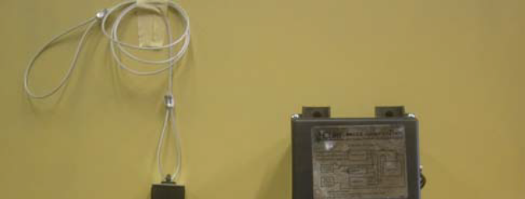


55
Coupling to the Tow Vehicle

^WARNING
An ineffective breakaway brake system can
result in a runaway trailer leading to death or
serious injury, if the coupler fails.

Connect the breakaway cable to the tow
vehicle, and NOT to the kingpin or its support.

Before towing the trailer, test the function of
the breakaway brake system. If the breakaway
brake system is not working, do not tow the
trailer; have it serviced or repaired.

Do not tow the trailer with the breakaway brake system ON because the brake will overheat which
can result in permanent brake failure.
^W
^WARNING
Failure to replace the pullpin will prevent
brakes from working, leading to loss of control, serious injury or death.

If you do not use your trailer for three or more months, or during winter months:

Store the battery indoors; and
Charge the battery every three months.

Replace the breakaway brake battery at intervals recommended by the battery manufacturer.

3.24. CONNECT THE ELECTRICAL CABLES
Connect the trailer lights to the tow vehicle's electrical system using the electrical connectors.
Check all lights for proper operation:
Clearance and Running Lights (Turn on tow vehicle headlights).
Brake Lights (Step on Tow vehicle brake pedal).
Turn Signals (Operate tow vehicle directional signal lever).

Check brakes for proper operation: While towing the trailer at less than 5 m.p.h., manually
operate the electric brake controller in the tow vehicle cab. You should feel the operation
of the trailer brakes.
^WARNING

56
Coupling to the Tow Vehicle
^W

^WARNING
Improper electrical connection between the tow vehicle and the trailer will result in inoperable lights and electric brakes, and can lead to collision.

Before each tow:
• Check that the taillights, brake lights and
turn signals work
• Check that the electric brakes work by
operating the brake controller inside the tow
vehicle.

3.25. UNCOUPLING THE FIFTH-WHEEL TRAILER WITH DROP-LEG JACK
Follow these steps to uncouple your fifth wheel hitch trailer from your tow vehicle

• Block trailer tires to prevent the trailer from rolling before jacking the trailer up.
• Disconnect the electrical connector.
• Disconnect the breakaway brake switch lanyard.
• If the tow vehicle has a tailgate, lower it.
• Make certain that ground surface below jack base will support trailer tongue load.
• Rotate the drop leg plunger pin handle so that the plunger pin is released from the
drop leg (see “Releasing Drop Leg Mechanism” figure).
• Push down on the drop leg base with your foot to place a drop leg to the desired
lowered position.

^ CAUTION
The drop legs are heavily spring loaded in the
lowered position. They will rapidly return to the upper position when released and can inflict serious bruises, scrapes or pinching.

Keep your feet, shins and hands well clear of
the drop legs and drop leg bases when
releasing the drop legs.

Always wear shoes or boots while performing
this operation.

• Rotate the plunger pin handle so that the plunger pin is attempting to engage the drop
leg (see “Releasing Drop Leg Mechanism” figure).
• Slowly raise your foot, permitting the drop leg to raise. The plunger pin will engage a
hole in the drop leg.
• Be sure the plunger pin is fully engaged. Push it in by hand if necessary. The bent
part of the plunger pin handle must be touching the plunger pin housing.
• If your trailer has two drop leg jacks, lower them both to the same level, following the
above instructions.

57
Coupling to the Tow Vehicle

^NOTICE
If the drop legs are not set at the same level,
one of the drop leg jacks can be overloaded
and can be damaged.

• Release the handle (or crank) from its holder and engage it with the jack shaft.
• Rotate the handle (or crank) clockwise to slowly extend the jack and transfer the
weight of the trailer tongue to the jack.
• On two speed jacks, pushing the handle shaft toward the gearbox can perform rapid
extension. This shifts the gearbox into a high speed mode.
• When the drop leg base contacts the ground, shift the gearbox into low speed mode
by pulling out on the handle shaft until it locks into low gear.

^NOTICE
Do not use high speed to lift the trailer, the
drop leg jack mechanism can be damaged.
High speed is used only to rapidly move the
drop leg base into contact with the ground.

• Continue to extend the jack(s), making sure that the ground is providing stable and
level support for the trailer.
• Turn the crank two or three turns to take some of the weight of the coupling. Do not
raise the fifth wheel off the kingpin plate.
• After the jack(s) are extended enough to permit driving the tow vehicle away,
disengage the jack handle from its shaft and return it to its holder. Do NOT drive the
tow vehicle yet!

Open the fifth wheel locks by:
• pulling the release handle, or
• using a separate pipe release handle to engage the solid stud on the secondary
Lock.

Slowly drive the tow vehicle away from the trailer.

Raise the tow vehicle tailgate.

58
Loading the Trailer

4. LOADING THE TRAILER

Improper trailer loading causes many accidents and deaths. To safely load a trailer, you must
consider:
Overall load weight;
Load weight distribution;
Proper tongue weight; and
Securing the load properly.

To determine that you have loaded the trailer within its rating, you must consider the distribution of
weight, as well as the total weight of the trailer and its contents. The trailer axles carry most of the
total weight of the trailer and its contents (Gross Vehicle Weight, or “GVW”). The remainder of the
total weight is carried by the tow vehicle hitch. It is essential for safe towing that the trailer-tongue
and tow vehicle hitch carry the proper amount of the loaded trailer weight, otherwise the trailer can
develop an undesirable sway at towing speeds, or the rear of the towing vehicle can be
overloaded. Read the “Tongue Weight” section below.

The load distribution must be such that no component part of the trailer is loaded beyond its
rating. This means that you must consider the rating of the tires, wheels and axles. For tandem
and triple axle trailers, you must make sure that the front-to-rear load distribution does not result in
overloading any axle.

Towing stability also depends on keeping the center of gravity as low as possible. Load heavy
items on the floor and over the axles. When loading additional items, be sure to maintain even
side-to-side weight distribution and proper tongue weight. The total weight of the trailer and its
contents must never exceed the total weight rating of the trailer (Gross Vehicle Weight Rating, or
“GVWR”).
^
^WARNING
An overloaded trailer can result in loss of
control of the trailer, leading to death or serious injury.
Do not load a trailer so that the weight on any
tire exceeds its rating.
Do not exceed the trailer Gross Vehicle Weight
Rating (GVWR) or the Gross Axle Weight
Rating (GAWR).

4.1. TONGUE WEIGHT
It is critical to have a portion of the trailer load carried by the tow vehicle. That is, the trailer
tongue must exert a downward force on the hitch. This is necessary for two reasons. First, the
proper amount of tongue weight is necessary for the tow vehicle to be able to maintain control of
the tow vehicle/trailer system. If, for example, the tongue exerts an upward pull on the hitch,
instead of pushing down on it (because the trailer is overloaded behind its axle(s)), the rear wheel

59
Loading the Trailer

of the tow vehicle can lose traction or grip and cause loss of control. Also, even if there is some
weight on the tongue, but not enough weight on the tongue, the trailer can become unstable at
high speeds. Remember, the faster you go the more likely the trailer is to sway.

If, on the other hand, there is too much tongue weight, the tow vehicle is prone to jack-knife.
Furthermore, the front wheels of the tow vehicle can be too lightly loaded and cause loss of
steering control and traction, if the front wheels are driving.

In addition to tow vehicle control, tongue weight is necessary to insure that the trailer axle(s) do
not exceed their Gross Axle Weight Rating (GAWR).

The table below has “rules of thumb” for proper tongue weight.

In the table below, the second column notes the rule of thumb percentage of total weight of the
trailer plus its cargo (Gross Vehicle Weight, or “GVW”) that should appear on the tongue of the
trailer. For example, a trailer with a gooseneck hitch, with a loaded weight of 12,000 pounds,
should have 20-25% (of 12,000 pounds) on the tongue. That is, the example trailer would have
2,400 to 3,000 pounds on its tongue.

Tongue Weight as a Percentage of Loaded Trailer Weight
Type of Hitch | Percentage
Ball Hitch (or Bumper Hitch) | 10–15%for large trailers  6-10% for smaller utility and cargo trailers  4-6% for boat trailers
Gooseneck Hitch &  Fifth Wheel Hitch | 20–25%

The numbers quoted above are for example purposes only and should be tailored to the
specific trailer. For questions regarding the actual percent of tongue weight for the trailer,
check with the manufacturer for specifics.

60
Loading the Trailer
^W

^WARNING
Improper tongue weight (load distribution) can
result in loss of control of the trailer, leading to
death or serious injury.

Make certain that tongue weight is within the
allowable range.

Be sure to:
• Distribute the load front-to-rear to provide
proper tongue weight (see chart);
• Distribute the load evenly, right and left, to
avoid tire overload; and
• Keep the center of gravity low.

4.2. CHECKING TONGUE WEIGHT
To check the tongue weight, the tow vehicle and trailer must be on level ground, as they will be
when the trailer is being towed.

For lighter trailers the recommended method of checking tongue weight is to use an accessory
called a “tongue weight scale.” If a tongue weight scale is not available from your dealer, call
Thuro-Bilt, Inc. at 541-670-8701 for assistance.

An alternate method of checking tongue weight involves the use of a bathroom scale. The loaded
trailer must be on a smooth and level surface, and you must block the trailer wheels, front and
rear.

^
^WARNING
An unrestrained trailer can fall off its support,
resulting in serious injury or death.

Before checking tongue weight, block trailer
wheels, front and rear.

Raise the tongue of the trailer with the jack.
Place a bathroom scale on the ground, directly below the coupler.
Place a strong block support (such as a cement block) on the scale – note the scale reading
for the weight of the block support.
Lower the tongue until the coupler rests on the block support and the jack is ½ inch above the
ground.
The scale reading, minus the weight of the block support is the tongue weight.

If the tongue weight exceeds the capacity of a bathroom scale, you can use “leverage” to
divide the tongue weight between the bathroom scale and another support Raise the
tongue of the trailer with the jack.

61
Loading the Trailer

For heavier trailers it is easier to go to a truck stop where there is a “certified” scale. Pull only the
tow vehicle onto the scale and get the weight. This weight must be less than your tow vehicle’s
GVWR. Pull the trailer onto the scale and decouple it from the tow vehicle, leaving just the trailer
on the scale. Get a “ticket”, which lists the total trailer weight. Re-connect the trailer to your tow
vehicle and the drive the tow vehicle wheels off the scale, just leaving the trailer axles on the
scale. Get a second “ticket”, which lists the trailer’s axle weight. Simple subtract the axle weight
from the total weight to determine the hitch weight.

While you are at the scale, you should weigh the entire combination vehicle. This result should be
less than the Gross Combined Weight Rating (GCWR) for your towing vehicle. Some scales allow
you to get individual axle weights also. If this is possible, get the tow vehicles front and rear axle
weights to make sure they are in the same proportion as the tow vehicle alone, and that the rear
axle is not overloaded. This is the best way to check that a weight distribution (or load leveling)
hitch is adjusted properly, i.e., you have the proper number of chain links attached to the snap-up
brackets.

4.3. SECURING THE CARGO
Since the trailer “ride” can be bumpy and rough, you must secure your cargo so that it does not
shift while the trailer is being towed.

^

^WARNING
Shifting cargo can result in loss of control of
the trailer, and can lead to death or serious
injury.
Tie down all loads with proper sized fasteners,
ropes, straps, etc.

4.4. LOADING CARGO (ENCLOSED TRAILER)
Couple the trailer to the tow vehicle before loading. The tongue of a bumper pull trailer can rise
during loading, before the cargo is properly distributed. To measure the tongue weight, you will
have to uncouple the trailer after it is loaded.

Do not transport people, containers of hazardous substances, cans or containers of flammable
substances. However, fuel in the tank of an off-road vehicle, or a car or motorcycle, etc., may be
carried inside of your enclosed cargo trailer.

62
Loading the Trailer
^W

^WARNING
Do not transport people inside the trailer, even
if it has living quarters. The transport of people
puts their lives at risk and may be illegal.

^WARNI
^WARNING
Do not transport flammable, explosive,
poisonous or other dangerous materials in your trailer.

Exceptions:
• Fuel in the tanks of vehicles that are being
towed.
• Fuel stored in proper containers used in
trailer living quarters for cooking.
• Fuel stored in the tank of an on-board
generator.

4.5. PREPARING THE TRAILER FOR LOADING
Before loading cargo into your enclosed trailer, inspect the interior of the trailer.

Enclosed trailers may be fitted with “D”-ring hold-downs, and/or a track system that can be used to
secure the cargo. Inspect the “D”-rings and track system for looseness or signs of bending before
loading the cargo onto the trailer.

^WARNING
Damaged or loose “D”-rings can break,
allowing cargo to become loose inside the
trailer. Loose cargo can shift the center of
gravity, and result in loss of control of the trailer.

Inspect “D”-rings, and test them for looseness
before loading cargo.

Do not use a damaged or loose “D”-ring to
secure cargo.

4.6. LOADING THE ENCLOSED TRAILER
Enclosed trailers may be fitted with a drop ramp door. The weight of the drop ramp door is
partially held by a spring and cable counterbalance assembly. If the spring and cable
counterbalance assembly is out of adjustment or worn out, it will not provide the expected
assistance for slow and careful lowering and raising of ramp.

63
Loading the Trailer
^WA

^WARNING
A spring and cable counterbalance can inflict
serious injury if it breaks, or if incorrectly
adjusted.

Inspect the cable and cable ends each time the
door is operated.
Do not attempt to service the counterbalance.
Take the trailer to your dealer for service.

Carefully lower the drop ramp to the ground.

Load the cargo up the drop ramp and into the trailer, with approximately 60% of the cargo in the
front half of the trailer. If the trailer has living quarters, the cargo area of your trailer will have
ventilation openings near the floor. Do not block these ventilation openings. These openings are
provided to exhaust potentially deadly fumes.
^W

^WARNING
Accumulation of hazardous fumes can cause
death or serious injury.

Do not block access to ventilation ports.

Secure the cargo to the trailer using appropriate straps, chains and tensioning devices.

Close the drop ramp door and secure the trailer door catch using a linchpin or other locking
device, so that the catch and door cannot open while the trailer is being towed.^WAR

^WARNING
If the door opens, your cargo may be ejected
onto the road, resulting in death or serious
injury to other drivers.

Always secure the door latch after closing.
Place a linchpin in the catch.

4.7. LOADING HORSES (HORSE TRAILER)
Couple the trailer to the tow vehicle before loading. This is essential for the bumper pull trailer
because the tongue of a bumper pull trailer can rise during loading, before the cargo is properly
distributed.

The cargo-carrying portion of a horse trailer is designed only for carrying horses. Do not transport
people, livestock, containers of hazardous substances, or containers of flammable substances.

64
Loading the Trailer
^WARNING

^WARNING
Do not transport people inside the trailer, even
if it has living quarters. The transport of people
puts their lives at risk and may be illegal.
^WARNIN

^WARNING
Do not carry “loose” livestock in your horse
trailer. They can cause the trailer to become
unstable and can result in loss of control.

You must use a trailer designed to carry
“loose” livestock.

Before loading a horse in your trailer, inspect the interior of the trailer. The interior of the trailer
must be smooth, and have no protruding objects. There should be no loose objects that could
move about and startle or injure the horse. Check the walls, floor, dividers, etc., for loose and
broken parts, welds, hinges, etc.

4.8. PREPARING THE HORSE TRAILER FOR LOADING
Open windows and vents to provide ventilation. Consider the weather and transport conditions
(i.e. on warm sunny days, maximum ventilation is required). Do not carry a horse without
providing ventilation, even in coldest weather. Ventilation is critical for the well being of your
horses. Know your horses and adjust ventilation for your horses’ comfort.

Be sure pivoting window latches are in a flush position, so they do not present a protrusion that
can injure your horse.

Tighten any loose or protruding screws in the walls.
Remove or secure loose objects, (i.e. butt bars, saddles, tack and equipment) so that items will
not move during towing.

Inspect for cracks at the welds on the divider hinges, and the welds on the tie rings. If you are
able to open any cracks in or near these welds by lifting the dividers or by twisting the tie rings,
have the weld repaired before loading your horses.

65
Loading the Trailer

^ CAUTION
The trailer interior may contain hazards to a
horse that can result in its serious injury or
death.

Before loading a horse, inspect the trailer
interior and adjust or repair all loose and
protruding features such as handles, loose or
broken parts of the trailer, etc.

Before towing trailer:
• Lock all stall dividers.
• Be sure all saddles, tack and equipment, as
well as horse(s), are prevented from being
thrown about.

^WARNING
Improper weld repair will lead to early failure of
the trailer structure and can cause serious
injury or death.

Do not repair cracked or broken welds unless
you have the skills and equipment to make a
proper repair. Have the welds repaired by your
dealer.

4.9. LOADING THE HORSE TRAILER
The trailering of horses introduces many variables that are not present in the trailering of nonliving
cargo. Horses are prone to take flight when they feel threatened or pain. In the confines of
a trailer, the flight response can cause serious injury or death to a human handler. Even
experienced and docile horses can be frightened.

Horses must be slowly acclimated to trailering. Be sure the horse’s first trips are short trips, so
you can gauge its reaction. Some will take to the experience easily, but others will strongly
protest. You must act according to your horse’s demeanor.

66
Loading the Trailer
^WA

^WARNING
When a horse is frightened, it is capable of
inflicting serious injury or death to a human
handler.

Know your horse’s temperament before
attempting to trailer it.

Handling a horse that is not trailer-acclimated
may result in injury or death, or damage to
your trailer.

Do not haul an unbroken horse in this trailer.

Horses must have a halter.

Open all stall dividers and lock them in their OPEN (against the wall) position.

If the trailer has living quarters, close and lock the door between the living quarters and the horse
area.

If the trailer is fitted with a drop ramp, carefully lower it to the ground.

If your trailer is fitted with swinging loading doors, open them fully and fasten them against the
side of the trailer using the door holdbacks.

Lead the horse into the trailer by a halter or lead rope. If the horse shows any signs of distress,
stop loading, and calm the horse.
^
^WARNING
Improper weight distribution of the horses in
the trailer will result in an unstable trailer.
Always load the first horse into the forward most stall.

Tie the horse to the trailer interior by fastening the quick connect or tying the lead rope to the tie
ring, or other facility provided on the trailer wall for attachment of the lead rope. A rule of thumb is
to leave about 18 inches of free rope between the attachment point on the trailer and the horse.

The layout of the horse trailer has been designed to safely contain your horse. The trailer is
equipped with stall dividers and tie rings to secure the horse. Restraining a horse without using a
combination of a tie-strap and stall divider may result in serious injury or death to the horse.

^ CAUTION
Failure to secure a horse using a tie strap
may result in its serious injury or death.

Close and lock the stall divider.
67
Loading the Trailer

If additional horses are to be loaded, repeat steps 5-7 above for each horse – lead the horse,
secure the horse, close and lock the stall divider.
After the last horse has been loaded, lock any unused dividers in the CLOSED (across the trailer)
position.

Double check that each horse is tied to the trailer and each stall divider is LOCKED in the
CLOSED position.

If your trailer is fitted with a butt bar or butt strap to keep the horse away from the door, hook and
lock the butt bar in place.

Close the trailer. Remove the door holdbacks and swing the hinged doors to a closed position, or
raise the drop ramp.

Secure the trailer door catch with a linchpin or similar device, so that the catch and door cannot
open while the trailer is being towed.

If your trailer is fitted with feed doors, close and secure them.

A
^WARNING
If the door opens, your cargo may be ejected
onto the road, resulting in death or serious
injury to other drivers.
Always secure the door latch after closing.
Place a linchpin in the catch.

Check the horses after 5 to 10 miles or 10 minutes of towing, and then at least once per hour
thereafter. Open a feed door or other access and look for signs of stress, cuts, or injury. On long
trips it is recommended that horses be removed from the trailer every 6-10 hours for exercise,
food and watering.
^WAR
N
^WARNING
Horses may kick when back door is opened.
Stay clear when opening back door.

4.10. LOADING LIVESTOCK (LIVESTOCK TRAILER)
Couple the trailer to the tow vehicle before loading. This is essential for the bumper pull trailer
because the tongue of a bumper pull trailer can rise during loading, before the cargo is properly
distributed.

The cargo-carrying portion of a livestock trailer is for carrying livestock (other than horses) only.
The livestock trailer does not have the equipment required for the safe transport of horses, e.g.
stall dividers, tie rings and a rubber floor mat. Do not transport people, containers of hazardous
substances, or containers of flammable substances.

68
Loading the Trailer
^W

^WARNING
Do not transport people inside the trailer, even
if it has living quarters. The transport of people
puts their lives at risk and may be illegal.

W
^WARNING
Do not transport flammable, explosive,
poisonous or other dangerous materials in your trailer.

^ CAUTION
Hauling a horse in a livestock trailer may
result in its serious injury or death.

Do not carry a horse in a livestock trailer.
Use a trailer designed to carry horses.

4.11. PREPARING THE LIVESTOCK TRAILER FOR LOADING
Before loading livestock in your livestock trailer, inspect the interior of the trailer. The interior of
the trailer must be smooth, and have no protruding objects, such as bolts, broken parts of trailer
interior, etc. A protruding object can injure your livestock.

Tighten any loose or protruding bolts in the walls.

Remove or secure loose objects, so no items will move during towing.

^ CAUTION
The interior space of a trailer may contain
hazards that result in serious injury or death
to trailered livestock.

Inspect the interior of the trailer before
loading livestock.

• Adjust or repair all loose and protruding
features.
• All cargo and equipment, besides the
livestock, must be prevented from being
thrown about before towing trailer.

69
Loading the Trailer

4.12. LOADING THE LIVESTOCK TRAILER
The trailering of livestock introduces many variables that are not present in the trailering of nonliving
cargo. Livestock may resist being loaded into a trailer.
^W

^WARNING
Large animals are capable of inflicting serious
injury or death to a human handler.
Know your animals’ temperament before
attempting to trailer them.

If the trailer is fitted with a drop ramp, carefully lower it to the ground.

With the trailer in position, open and secure the loading door (either swinging or roll-up).

Open and secure the interior gates as necessary.

Guide the livestock into the trailer.

Gate the livestock tightly to keep them from moving or falling during transportation.

Close the loading doors (either swinging or roll-up) and raise the drop ramp.

Secure the trailer door catch with a linchpin or similar device, so that the catch and door cannot
open while the trailer is being towed.
^W

^WARNING
If the door opens, your cargo may be ejected
onto the road, resulting in death or serious
injury to other drivers.
Always secure the door latch after closing.
Place a linchpin in the catch.

70
Checking the Trailer Before & During Each Tow

5. CHECKING THE TRAILER BEFORE & DURING EACH TOW

5.1. PRE-TOW CHECKLIST
Before towing, double-check all of these items: See “7.1 Inspection, Service & Maintenance Summary Charts,”
for more information.

• Tires, wheels and lug nuts (see the “Major Hazards” section starting on page 1 of this manual)

• Tire Pressure. Inflate tire on trailer and tow vehicle to the pressure stated on the VIN /
Certification label.

• Coupler secured and locked (see the “Coupling and Uncoupling the Trailer” section starting on
page 32 of this manual)

• Safety chains properly rigged to tow vehicle, not to hitch or ball (see the “Coupling to the Tow
Vehicle” chapter starting at Page 29 of this manual)

• Test of lights: Tail, Stop, and Turn Lights

• Test trailer brakes.

• Safety breakaway switch cable fastened to tow vehicle, not to safety chains (see the
“Coupling to the Tow Vehicle” chapter starting at Page 29 of this manual)

• Cargo properly loaded, balanced and tied down (see the “Loading the Trailer” chapter starting
at page 59 of this manual)

• Tongue weight and weight distribution set-up.

• Doors and gates latched and secured

• Fire extinguisher

• Flares and reflectors

5.2. MAKE REGULAR STOPS
After each 50 miles, or one hour of towing, stop and check the following items:

• Coupler secured

• Safety chains are fastened and not dragging

• Cargo secured

• Cargo door latched and secured

• Live Animal Cargo Checks 4.3.3.2

71
Breaking in a New Trailer
6. BREAKING IN A NEW TRAILER

6.1. RETIGHTEN LUG NUTS AT FIRST 10, 25 & 50 MILES
Wheel lugs can shift and settle quickly after being first assembled, and must be checked after the first 10, 25
and 50 miles of driving. Failure to perform this check may result in a wheel coming loose from the trailer,
causing a crash leading to death or serious injury.

^WARNING
Lug nuts are prone to loosen after initial
installation, which can lead to death or serious
injury.

Check lug nuts for tightness on a new trailer or
when wheel(s) have been remounted after the
first 10, 25 and 50 miles of driving.

See Section 7.26 page 82 on Proper Torqing Technique.

6.2. ADJUST BRAKE SHOES AT FIRST 200 MILES
Brake shoes and drums experience a rapid initial wear. The brakes must be adjusted after the first 200 miles
of use, and each 3,000 miles thereafter. Some axles are fitted with a mechanism that will automatically adjust
the brake shoes when the trailer is “hard braked” from a rearward direction. Read your axle and brake manual
to see if your brakes adjust automatically. If you do not have the axle and brake manual, call Thuro-Bilt, Inc. at
541-670-8701 for a free copy.

A hard stop is used to:
• Confirm that the brakes work;
• Confirm that the trailer brakes are properly synchronized with the tow vehicle brakes using the
brake controller in the tow vehicle
• Adjust the brake shoes as necessary.
• For surge brakes check the Master cylinder reservoir for fluid.
If your trailer is not fitted with automatically adjusting brakes, the brakes will need to be manually adjusted. See
section 7.7, “Manually Adjusting Brake Shoes,” for instructions.

6.3. SYNCHRONIZING THE BRAKE SYSTEMS
Trailer brakes are designed to work in synchronization with the brakes on the tow vehicle. When the tow
vehicle and trailer braking systems are synchronized, both braking systems contribute to slowing, and the
tongue of the trailer will neither dive nor rise sharply.

^WARNING
If trailer and tow vehicle brakes do not work
properly together, death or serious injury can
occur.

Road test the brakes in a safe area at no more
than 30 m.p.h. before each tow.

To insure safe brake performance and synchronization, read and follow the axle/brake and the brake controller
manufacturers’ instructions. If you do not have these instructions, call Thuro-Bilt, Inc. at 541-670-8701
for a free copy.

TIRE PRESSURE
Check tire pressures on both the trailer and tow vehicle. Inflate to the maximum shown on the VIN /
Certification Label Inspection, Service & Maintenance.

72

7. Inspection, Service & Maintenance

7.1. INSPECTION, SERVICE & MAINTENANCE SUMMARY CHARTS
You must inspect, maintain and service your trailer regularly to insure safe and reliable operation. If you cannot
or are unsure how to perform the items listed here, have your dealer do them. Note: In addition to this manual,
also check the relevant component manufacturer's manual.

Inspection and Service before Each Use

Item | Item Inspection / Service | Manual Section Reference
Breakaway Brakes  > Electric  > Hydraulic | Check operation.  Check fluid level. | Sections 3.10, 3.17, 3.23  Sections 7.8, 7.9, 7.10, 7.11
Breakaway Battery | Fully charged, connections  Clean. | Sections 3.10, 3.17, 3.23
Brakes, all types | Check operation. | Section 6
Shoes and Drums | Adjust. | Section 6 & Section 7.6
Brakes, Hydraulic – Vacuum  Actuated | Check gauge for proper  vacuum of 18 In. Hg. (inches of  mercury) | Sections 7.12, 7.13, 7.14, 7.15
Coupler and Hitch Ball | Check for cracks, pits, and  flats. Replace w/ball & coupler  having trailer GVW Rating.  Grease.  Check locking device & replace. | Section 3.5 & Section 7.16
Gooseneck Ball | Check for cracks, pits, and  flats. Replace w/ball & coupler  having trailer GVW Rating.  Grease.  Check locking device & replace  when worn. | Section 3.13  Section 7.17
Fifth Wheel & Kingpin | Check for cracks,  Grease.  Check locking device & replace  when worn. | Section 3.25  Section 7.18
Safety Chain(s) & Hooks | Check for wear and damage. | Sections 3.9, 3.16
Tires | Check tire pressure when cold.  Inflate as needed. | Sections 2 & Section 5  Section 7.22
Wheels - Lug Nuts (Bolts) & Hub | Check for tightness. Tighten.  For new and remounted wheels, check  torque after first 10, 25 & 50  miles of driving and after any  impact. | Section 5 & Section 6  Section 7.22

73
Inspection, Service & Maintenance

Inspection and Service each 3 Months or 3,000 Miles
Item | Inspection / Service | Manual Section Reference
Structure  > Rubber mats and floor  > Hinges, Doors and dividers | Remove mats. Wash both sides.  Wash floor.  Inspect. Repair or replace  damaged, worn or broken parts. | Sections 4.5, 4.8, 4.11  Section 7.3

Inspection and Service each 6 Months or 6,000 Miles
Item | Inspection / Service | Manual Section Reference
Tires | Rotate @ 5,000 miles. | Section 2 & Section 7.22
Brakes, electric  > Magnets  > Controller (in tow vehicle) | Check wear and current draw.  Check power output (amperage)  and modulation. | Sections 7.6, 7.7, 7.8, 7.9, 7.10, 7.11  See Controller Mfr’s Manual
Structure  > Roof Vents  > Windows | Clean dirt buildup, lubricate  hinges and slides. | Section 7.3
Tires | Inspect tread and sidewalls  thoroughly.  Replace tire when treads are  worn, when sidewall has a  bulge, or sidewall is worn. | Section 2  Section 7.22

Inspection and Service Each Year or 12,000 Miles
Item | Inspection / Service | Manual Section Reference
Brakes, all types  > Shoes and drums | Check for scoring and wear.  Replace per manufacturers  Specifications. | Sections 7.6, 7.7, 7.8, 7.9, 7.10,  7.11, 7.12, 7.13, 7.14, 7.15  See Brake Mfr’s Manual
Jack, Drop-leg | Grease gears at top | See Jack Mfr’s Manual
Structure  > Frame members  > Welds  > Slide-out | Inspect all frame members,  bolts & rivets. Repair or replace  damaged, worn or broken parts.  Inspect all welds. Repair as  Needed.  Clean dirt build-up. Lubricate  slides, shafts and gears. | Sections 7.3, 7.4
Wheels  > Sealed Bearings (Hubs)  > UNSEALED Bearings (Hubs)  > Rims | Check and confirm free running.  Replace if not (sealed bearings  are not serviceable).  Disassemble / inspect /  assemble and repack. Replace  promptly if immersed in water.  Inspect for cracks & dents.  Replace as needed. | Sections 7.23, 7.24, 7.25, 7.26  See Axle Mfr’s Manual
Structure  > Axle Attachment Bolts | Check BY DEALER | Section 7.3

74

Inspection, Service & Maintenance

7.2. INSPECTION & SERVICE INSTRUCTIONS
W^
^WARNING
Worn or broken suspension parts can cause
loss of control and injury may result.
Have trailer professionally inspected annually
and after any impact.

To perform many of the inspection and maintenance activities, you must jack up the trailer. “Jacking Points for
All Trailers” figure indicates the general areas where jacks and jack stands may be applied.

When jacking and using jack stands, place them so as to clear wiring, brake lines, and suspension parts
(springs, torsion bars, etc.). Place jacks and jack stands inside of the perimeter strip on the supporting
structure to which the axles are attached.

Jacking Points for Trailer
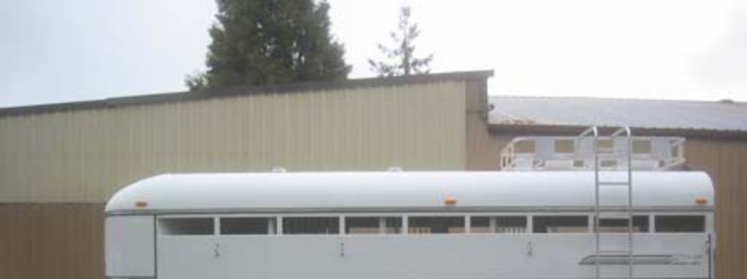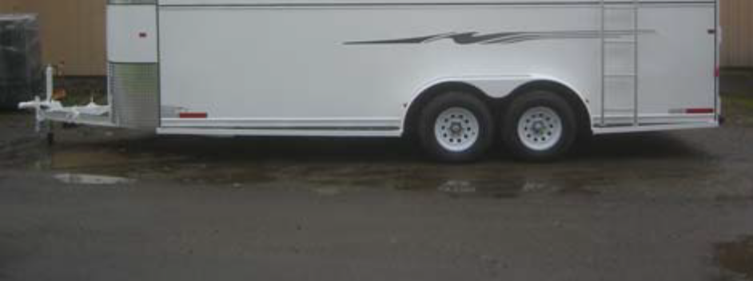

^
^WARNING
Never crawl under your trailer unless it is on
firm and level ground and resting on properly
placed and secured jack stands.

7.3. TRAILER STRUCTURE
Because the trailer floor receives the most abuse, it will most likely corrode before any other part of the
structure. This is particularly true for horse and livestock trailers, having floors subjected to urine and manure.
The urine and manure are corrosive to the metal or wood flooring and other structural parts of the trailer.

75
Inspection, Service & Maintenance

Remove the rubber mats from the floor of the trailer, and wash them, at least every three months. Using a
power washer and a detergent solution, wash both sides of the rubber mat, as well as the floor and walls of the
trailer. Rinse the rubber mat and the trailer floor and walls. Be sure the rubber mat and trailer floor are
completely dry before replacing the rubber mat.

7.4. WELDS
All welds can crack or fail when subjected to heavy loads or movement of cargo that was not properly tied to
prevent movement. Any time that you know or suspect that the trailer has been subjected to heavy loads or
movement of cargo, immediately inspect the welds and fasteners for damage. To prevent severe damage to
your trailer, inspect all of the welds for cracks or failure at least once a year.
^

^WARNING
Improper weld repair will lead to early failure of
the trailer structure and can cause serious
injury or death.

Do not repair cracked or broken welds unless
you have the skills and equipment to make a
proper repair. If not, have the welds repaired
by your dealer.

7.5. DROP RAMP TORSION SPRINGS
If your trailer has a drop-ramp door, the weight of the door may be partially held by a torsion spring and a cable.
Stand to the side when opening the drop ramp. You could be hurt if you are behind the drop ramp and the
counterbalance does not work.

Inspect the cable and cable ends regularly for fraying and signs of loosening. If released, a torsion spring can
inflict serious injury.

The torsion spring and cable are not user serviceable. The torsion spring must be serviced by a person who is
trained in torsion spring safety.

7.6. BRAKE SHOES & DRUMS
Properly functioning brake shoes and drums are essential to ensure safety. You must have your dealer inspect
these components at least once per year, or each 12,000 miles.

The brake shoes must be adjusted after the first 200 miles of use, and each 3,000 miles thereafter. Most axles
are fitted with a brake mechanism that will automatically adjust the brake shoes when the trailer is “hard
braked” from a rearward direction. Read your axle and brake manual to see how to adjust your brakes. If you
do not have this manual, call Thuro-Bilt, Inc. at 541-670-8701 for a free copy.

7.7. MANUALLY ADJUSTING BRAKE SHOES
Some braking systems are not automatically adjusted by hard stopping. These brakes require manual
adjustment. The following steps apply to adjust most manually adjustable brakes. Read your axle and brake
manual to see how to adjust your brakes. If you do not have this manual, call Thuro-Bilt, Inc. at 541-670-8701
for a free copy.

76
Inspection, Service & Maintenance

• Jack up the trailer and secure it on adequate capacity jack stands.
• Be sure the wheel and brake drum rotate freely.
• Remove the adjusting-hole cover from the adjusting slot on the bottom of the brake backing plate.
• With a screwdriver or standard adjusting tool, rotate the starwheel of the adjuster assembly to expand
the brake shoes. Adjust the brake shoes out until the pressure of the linings against the drum makes
the wheel very difficult to turn. Note: Your trailer maybe equipped with drop spindle axles. See axle
manual for your axle type. You will need a modified adjusting tool for adjusting the brakes in these
axles. With drop spindle axles, a modified adjusting tool with about an 80 degree angle should be
used.
• Rotate the star wheel in the opposite direction until the wheel turns freely with a slight drag.
• Replace the adjusting-hole cover.
• Repeat the above procedure on all brakes.
• Lower the trailer to the ground.

7.8. BRAKES, ELECTRIC
Two different types of electric brakes may be present on the trailer: an emergency electric breakaway system,
which acts only if the trailer comes loose from the hitch and the breakaway pin is pulled. The other brake is an
electric braking system that acts whenever the brakes of the tow vehicle are applied.

7.9. BREAKAWAY BRAKE
This battery supplies the power to operate the trailer brakes if the trailer uncouples from the tow vehicle. Be
sure to check, maintain and replace the battery according to the battery manufacturer’ instructions.

This switch causes the breakaway battery to operate the electric brakes if the trailer uncouples from the tow
vehicle.

The pull cable for the pull pin is connected to the tow vehicle, and the switch is connected to the trailer. To
check for proper functioning of the switch, battery and brakes, you must pull the pin from the switch and confirm
that the brakes apply to each wheel. You can do this by trying to pull the trailer with the tow vehicle, after
pulling the pin. The trailer brakes may not lock, but you will notice that a greater force is needed to pull the
trailer.
^
^WARNING
If electric breakaway brakes do not operate
when trailer is uncoupled from the tow vehicle,
death or serious injury can occur.
Check emergency breakaway brake system
BEFORE each tow.

7.10. TOW VEHICLE OPERATED ELECTRIC BRAKES
The electric brakes that operate in conjunction with the tow vehicle brakes must be “synchronized” so that
braking is properly distributed to the tow vehicle brakes and the trailer brakes. For proper operation and
synchronization, read and follow the axle/brake and the brake controller manufacturers’ instructions. If you do
not have these instructions, call Thuro-Bilt, Inc. at 541-670-8701 for a free copy.

77
Inspection, Service & Maintenance

7.11. MAGNETS FOR ALL ELECTRIC BRAKES
To make certain an electrically-operated braking system will function properly, you must have your dealer
inspect the magnets at least once a year, or each 12,000 miles. See the brake manual for wear and current
inspection instructions.

7.12. BRAKES, HYDRAULIC (VACUUM, AIR or ELECTRIC OPERATED)
If your trailer has hydraulically-operated brakes, they function the same way the hydraulic brakes do on your
tow vehicle. The hydraulic braking system must be inspected by a dealer, at least as often as the brakes on
the tow vehicle, but no less than once per year. This inspection includes an assessment of the condition and
proper operation of the wheel cylinders, brake shoes, brake drums and hubs.

You must check the fluid level in the master cylinder reservoir at least every three months. If you tow your
trailer an average of 1,000 miles per month in a hot and dry environment, you must check the brake fluid level
once a month. The brake fluid reservoir is located on the tongue of the trailer or near the gooseneck. Fill with
DOT 4 brake fluid.

7.13. VACUUM-OPERATED HYDRAULIC
When towing a trailer, the vacuum gauge, which is located inside the cab of the tow vehicle, must indicate 18
In. Hg. (inches of mercury) or more at all times.
^WA
^WARNING
If the vacuum gauge in tow vehicle is not at or
above 18 In. Hg. (inches of mercury), damage
to the brake system will result and the brakes
may become inoperable.

7.14. AIR PRESSURE-OPERATED HYDRAULIC
Air/hydraulic braking systems are typically used when the tow vehicle has a diesel engine. The tow vehicle has
an air compressor that routes the air to an air/hydraulic mechanism, which sends brake fluid to the wheel
cylinders.

The air pressure gauge in your tow vehicle indicates the current air pressure. See your tow vehicle manual for
the proper air pressure.

7.15. ELECTRICAL-OPERATED HYDRAULIC
Electric/hydraulic braking systems, which are mounted on the trailer, use a small electrically-driven pump to
generate hydraulic pressure, which operates the brake cylinders. Like electrical brakes, an electric/hydraulic
braking system is operated by an electrical signal from the tow vehicle.

7.16. COUPLER & BALL
The coupler on the trailer connects to the ball attached to the hitch on the tow vehicle. The coupler, ball and
hitch transfer the towing forces between the tow vehicle and the trailer. Before each tow, coat the ball with a
thin layer of automotive bearing grease to reduce wear and ensure proper operation; and check the locking
device that secures the coupler to the ball for proper operation.

See the coupler manufacturer’s manual for other inspection and maintenance activities. If you do not have this
manual, call Thuro-Bilt, Inc. at 541-670-8701 for a free copy.

78
Inspection, Service & Maintenance

If you see or feel evidence of wear, such as flat spots, deformations, pitting or corrosion, on the ball or coupler,
immediately have your dealer inspect them to determine the proper action to prevent possible failure of the ball
and coupler system. All bent or broken coupler parts must be replaced before towing the trailer.

The coupler handle lever must be able to rotate freely and automatically snap into the latched position. Oil the
pivot points, sliding surfaces, and spring ends with SAE 30W motor oil. Keep the ball pocket and latch
mechanism clean. Dirt or contamination can prevent proper operation of the latching mechanism.

When replacing a ball, the load rating must match or exceed the GVWR of the trailer.

7.17. GOOSENECK
The gooseneck receiver on the trailer connects to a hitch-mounted ball on the towing vehicle. The receiver,
ball and hitch transfer the towing forces between the tow vehicle and the trailer. Check the locking device that
secures the receiver to the ball for proper operation.

See the gooseneck ball receiver manufacturer’s manual for other inspection and maintenance activities. If you
do not have a manual for the receiver, call Thuro-Bilt, Inc. at 541-670-8701 for a free copy.

If you see or can feel evidence of wear, such as flat spots, pitting or corrosion, on the ball or receiver,
immediately have your dealer inspect them to determine the proper action to prevent possible failure of the ball
and receiver system.

When replacing a ball, the load rating must match or exceed the GVWR of the trailer.

7.18. FIFTH WHEEL KINGPIN
Before each tow, inspect the fifth wheel and kingpin for wear, and coat the contact surface of the fifth wheel
plate with water-resistant Lithium-base grease. If you see evidence of wear on the fifth wheel or kingpin,
immediately have your dealer inspect them to determine the proper action to prevent failure of the fifth wheel
and kingpin system.

See the manual prepared by the manufacturer of the fifth wheel and kingpin for other inspection and
maintenance activities.

7.19. LANDING LEG OR JACK
If a grease fitting is present, you must use a grease gun to lubricate the jack mechanism. Grease the gears in
the top of hand-cranked jacks once a year, by removing the top of the jack and pumping or hand packing
grease into the gears.

7.20. LIGHTS & SIGNALS
Before each tow, check the trailer taillights, stoplights, turn signals and any clearance lights for proper
operation.
^W
^WARNING
Improper operating taillights, stoplights and
turn signals can cause collisions.
Check all lights before each tow.

79
Inspection, Service & Maintenance

7.21. ACCESSORY BATTERY
Your trailer may be outfitted with an accessory battery that operates lighting, electric landing gear, slide-outs or
other accessories. An accessory battery may be kept charged either by the tow vehicle or by the generator or
shore power. See the manual for the accessory battery.

A disconnect switch may be provided to disconnect the accessory battery when you do not plan to be using the
trailer for an extended period, such as seasonal storage. If there is no disconnect switch, then remove the
cables from the battery terminals.

The accessory battery must be kept in a charged condition during storage. The battery could freeze and break
if it becomes discharged.

7.22. TIRES
Trailer tires may be worn out even though they still have plenty of tread left. This is because trailer tires have to
carry a lot of weight all the time, even when not in use. It is actually better for the tire to be rolling down the road
than to be idle. During use, the tire releases lubricants that are beneficial to tire life. Using the trailer tires often
also helps prevent flat spots from developing.

The main cause of tire failure is improper inflation. Check the cold tire inflation pressures at least once a week
for proper inflation levels. “Cold” means that the tires are at the same temperature as the surrounding air, such
as when the vehicle has been parked overnight. Wheel and tire manufacturers recommend adjusting the air
pressure to the trailer manufacturer’s recommended cold inflation pressure, in pounds per square inch (PSI)
stated on the vehicle’s Federal Certification Label or Tire Placard when the trailer is loaded to its gross vehicle
weight rating (GVWR). If the tires are inflated to less than the recommended inflation level or the GVWR of the
trailer is exceeded, the load carrying capacity of the tire could be dramatically affected. If the tires are inflated
more than the recommended inflation level, handling characteristics of the tow vehicle/trailer combination could
be affected. Refer to the owner’s manual or talk to your dealer or vehicle manufacturer if you have any
questions regarding proper inflation practices.

Tires can lose air over a period of time. In fact, tires can lose 1 to 3 PSI per month. This is because molecules
of air, under pressure, weave their way from the inside of the tire, through the rubber, to the outside. A drop in
tire pressure could cause the tire to become overloaded, leading to excessive heat buildup. If a trailer tire is
under-inflated, even for a short period of time, the tire could suffer internal damage.

High speed towing in hot conditions degrades trailer tires significantly. As heat builds up during driving, the
tire’s internal structure starts to breakdown, compromising the strength of the tire. It is recommended to drive at
moderate speeds.

Statistics indicate the average life of a trailer tire is about five years under normal use and maintenance
conditions. After three years, replacing the trailer tires with new ones should be considered, even if the tires
have adequate tread depth. Some experts claim that after five years, trailer tires are considered worn out and
should be replaced, even if they have had minimal or no use. This is such a general statement that it may not
apply in all cases. It is best to have your tires inspected by a tire supplier to determine if your tires need to be
replaced.

If you are storing your trailer for an extended period, make sure the tires are fully inflated to the maximum rated
pressure and that you store them in a cool, dry place, such as a garage. Use tire covers to protect the trailer
tires from the harsh effects of the sun.

80
Inspection, Service & Maintenance

^WARNING
Worn, damaged or under-inflated tires can
cause loss of control, resulting in damage,
serious injury and possibly death.
Inspect tires before each tow.

7.23. WHEEL RIMS
If the trailer has been struck, or impacted, on or near the wheels, or if the trailer has struck a curb, inspect the
rims for damage (i.e. being out of round); and replace any damaged wheel. Inspect the wheels for damage
every year, even if no obvious impact has occurred.

7.24. WHEELS, BEARINGS & LUG NUTS
A loose, worn or damaged wheel bearing is the most common cause of brakes that grab.

To check your bearings, jack trailer and check wheels for side-to-side looseness. If the wheels are loose, or
spin with a wobble, the bearings must be serviced or replaced.

7.25. UNSEALED BEARINGS (HUBS)
If your trailer has unsealed axle bearings, they must be inspected and lubricated once a year or 12,000 miles to
insure safe operation of your trailer.

If a trailer wheel bearing is immersed in water, it must be replaced.

If your trailer has not been used for an extended amount of time, have the bearings inspected and packed more
frequently, at least every six months and prior to use.

Exploded view of Wheel Bearing
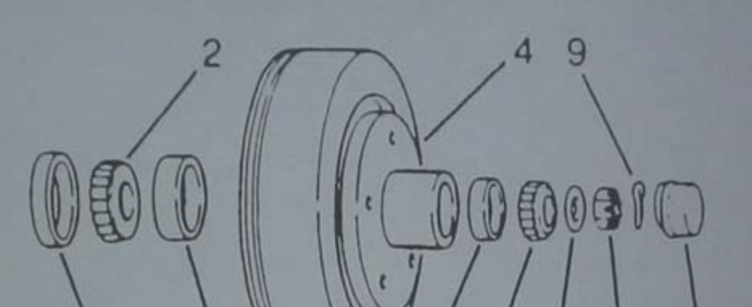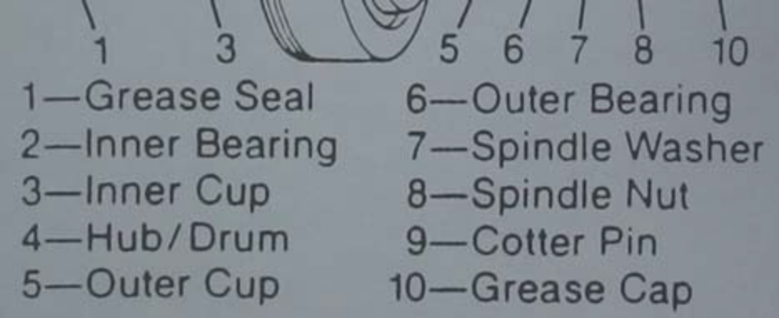

Follow the steps below to disassemble and service the UNSEALED wheel bearings.

• After removing the grease cap, cotter pin, spindle nut and spindle washer (items 7-10 in “Exploded
Wheel Bearing” figure), remove the hub and drum to inspect the bearings for wear and damage.
81
Inspection, Service & Maintenance

• Replace bearings that have flat spots on rollers, broken roller cages, rust or pitting. Always replace
bearings and cups in sets. The inner and outer bearings are to be replaced at the same time.
• Replace seals that have nicks, tears or wear.
• Lubricate the bearings with a high quality EP-2 automotive wheel bearing grease.

Every time the wheel hub is removed and the bearings are reassembled, follow the steps below to check the
wheel bearings for free running and adjust.

• Turn the hub slowly, by hand, while tightening the spindle nut, until you can no longer turn the hub by
hand.
• Loosen the spindle nut just until you are able to turn it (the spindle nut) by hand. Do not turn the hub
while the spindle nut is loose.
• Put a new cotter pin through the spindle nut and axle.
• Check the adjustments. Both the hub and the spindle nut should be able to move freely (the spindle
nut motion will be limited by the cotter pin).

7.26. LUG NUTS (BOLTS)
Being sure wheel mounting nuts (lug nuts) on trailer wheels are tight and properly torqued is an important
responsibility that trailer owners and users need to be familiar with and practice. Inadequate and/or
inappropriate wheel nut torque (tightness) is a major reason that lug nuts loosen in service. Loose lug nuts can
rapidly lead to a wheel separation with potentially serious safety consequences.

Lug nuts are prone to loosen right after a wheel is mounted to a hub. When driving on a new or remounted
wheel, check the lug nut tightness often during the first few hundred miles of the trailer’s use, especially after
the first 10, 25 and 50 miles of driving, before each tow, and at least twice per year thereafter.
^
^
^WARNING
Lug nuts are prone to loosen after initial
installation, which can lead to death or serious
injury.
Check lug nuts for tightness on a new trailer or
when wheel(s) have been remounted after the
first 10, 25 and 50 miles of driving.

^
^WARNING
Metal creep between the wheel rim and lug
nuts will cause rim to loosen and could result in a wheel coming off, leading to death or serious injury.
Tighten lug nuts before each tow.

Tighten the lug nuts to the proper torque for the axle size on your trailer to prevent wheels from coming loose.
Use a torque wrench to tighten the fasteners. The only way to be certain you have checked the torque or
torqued the lug nuts to the proper torque is with a torque wrench. Four-way wrenches, ratchets, and similar
tools can be useful for short-term emergency repairs, but are not appropriate tools for adequately checking lug
nut torque. You must use a torque wrench to adequately indicate the torque that you are applying to the lug
nut. If you do not have a torque wrench, tighten the fasteners with a lug wrench as much as you can, then
have a service garage or dealer tighten the lug nuts to the proper torque. Over-tightening will result in breaking
the studs or permanently deforming the mounting stud holes in the wheels.

82
Inspection, Service & Maintenance

Keep a record of the date and approximate mileage when you check the lug nut torque. Note any lug nut that
has lost torque. Investigate the reason(s) if the lug nut torque is not maintained after more than one re-torque
application, because this indicates there is something wrong with the lug nuts, nut studs, wheels and/or hubs
and should be corrected.

Contact your dealer or vehicle manufacturer immediately if you experience any persistent lug nut loosening or
any other lug, wheel or axle problems.

In the event of a wheel separation incident, notify the vehicle manufacturer and dealer. Seek prompt
professional assistance in assessing the trailer and its gear, and retain, but don’t re-use involved lugs, wheels
and studs. Don’t repair or service the trailer yourself. Call a trained technician.

Lug Nut Torque – Steel Wheels

Axle Rating  Pounds | Stud Size | Dry Torque  Foot-pounds
3,500 to 7,000 | ½ inch | 85lb -95lb

Dry Torque Foot-pounds is determined by manufacturer.

83
Warning Stickers on the Trailer
8. WARNING STICKERS ON THE TRAILER

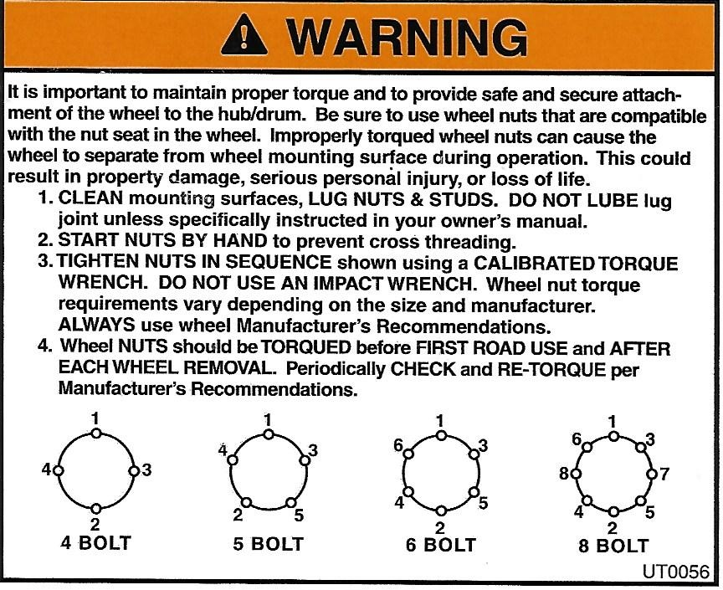
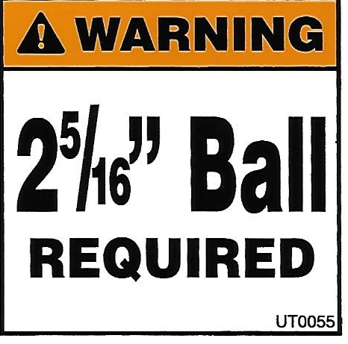
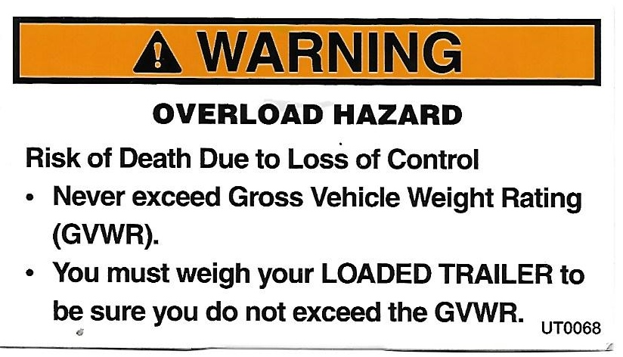
84

Warning Stickers on the Trailer

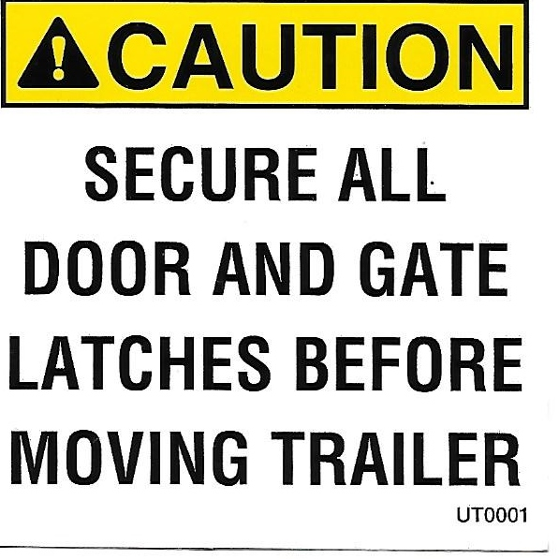

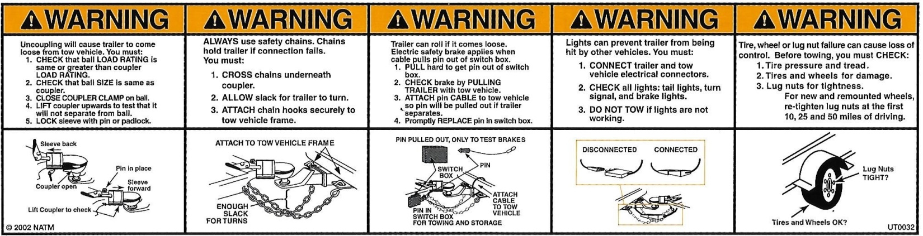

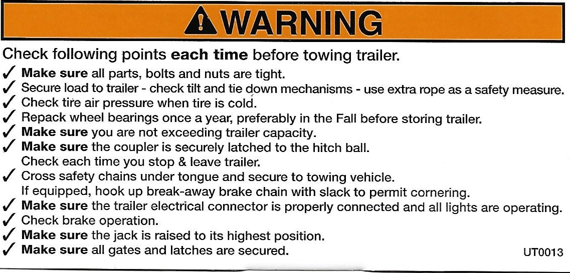

85

Warning Stickers on the Trailer

This Warning Sticker is placed on top of each fender. DO NOT STEP ON THE FENDERS, THEY ARE NOT A STEP.
Action is unsafe and could result of injury or damage to the trailer, which will not be covered under warranty.

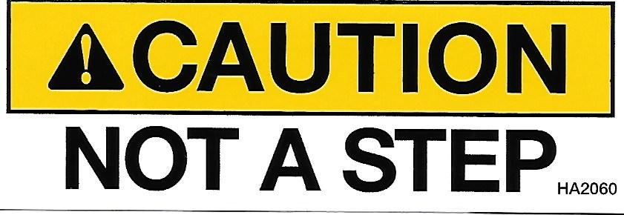

^WARNING
DO NOT USE THE HANDLES ON THE DROP DOWN WINDOWS AS ROPE TIES. SEE PHOTO.

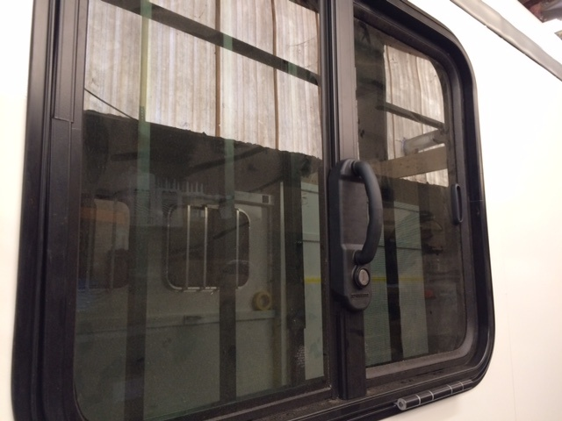

^NOTICE
MAKE SURE AND UNLATCH THE REAR DOOR HOLD BACK BEFORE ATTEMPTING TO CLOSE THE REAR DOOR. SEE PHOTOS.

LATCHED UNLATCHED
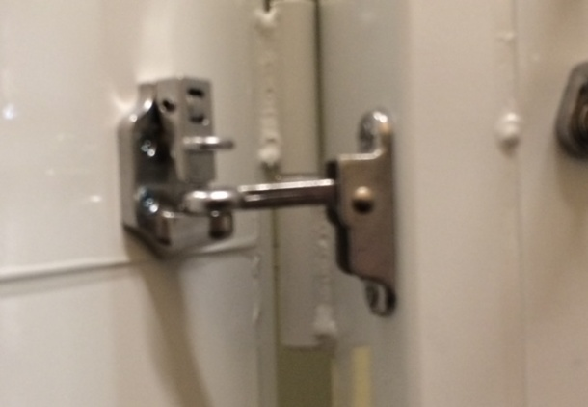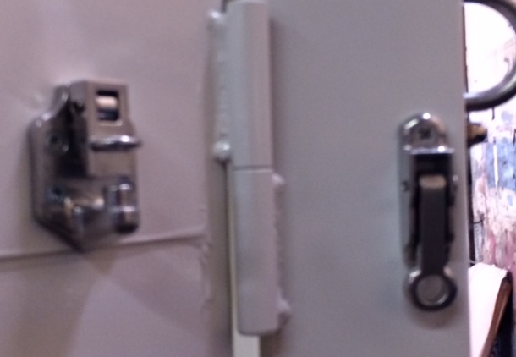

86

